Stats debunk South Dakota's brain drain myth
Written by Steve Young Dec 11, 2012
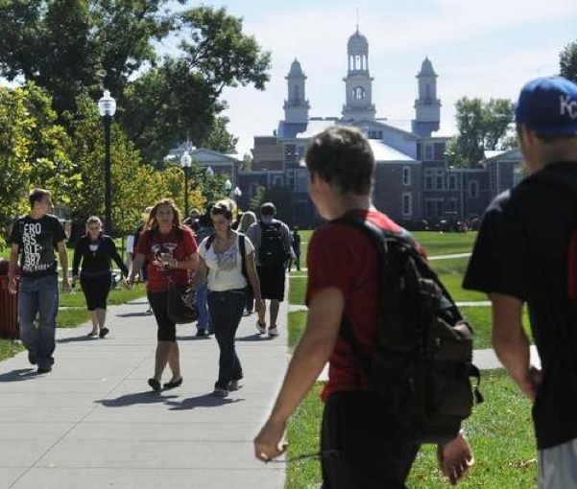
South Dakota's universities have reversed a long trend and now are attracting more out-of-state students than in-state students leaving the state. / Emily Spartz / Argus Leader
Importing students
The U.S. Bureau of Labor Statistics projects that 41,000 new jobs will be created in South Dakota between 2008 and 2018, many of those requiring bachelor and post-graduate degrees. With smaller high school graduating classes in the state, post-secondary institutions in South Dakota need to recruit more students from out of state and around the world to educate and help fill those jobs.
Here’s a comparative look at the number of South Dakotans leaving the state as college freshmen to go to school as opposed to the number of nonresident freshmen coming to the state’s public university system during the past 15 years.
Year | Freshmenleaving the state | Nonresidentfreshmencoming in | Netmigration
1995-96 | 1,514 | 1,339 | -175
1997-98 | 1,617 | 1,453 | -164
1999-00 | 1,844 | 1,776 | -68
2001-02 | 1,851 | 1,751 | -100
2003-04 | 1,819 | 1,948 | 129
2005-06 | 1,513 | 2,003 | 490
2007-08 | 1,564 | 2,134 | 570
2009-10 | 1,458 | 2,288 | 830
South Dakota’s intellectual brain drain isn’t nearly as cataclysmic as some might suggest, officials with the state’s public and private universities say.
In fact, recent trends seem to indicate that South Dakota is doing a better job of luring out-of-staters across our borders to go to college and keeping them here once they graduate.
“It’s been a perception for a long time that our young people leave us, go study elsewhere and then settle elsewhere,” Jack Warner, executive director of the state Board of Regents, said. “That trend was true until about the turn of the century ... and the trend now is advancing in the other direction.”
In reports that regents will mull this week during their regular meeting in Spearfish, statistics confirm that reversal. A decade ago, 100 more freshmen were leaving South Dakota to pursue a post-secondary education than were coming into the state. In the most recent year statistics are available for the public universities, the 2009-2010 academic year, 1,458 South Dakotans went elsewhere for college, while 2,288 out-of-staters came to universities here — a difference of plus-830.
That’s good news considering that almost three-fourths of South Dakota residents who graduate from a public university in this state stay here to either work or seek further education. And almost a third of nonresident students who graduate from the regental system stay in South Dakota to work or go to more school.
The trend is similar for private schools. At Augustana College, about 68 percent of its incoming freshmen classes come from other states, but 75 percent of its graduates report staying in South Dakota when they take a job. At the University of Sioux Falls, where about half of incoming freshmen are from out of state, about 85 percent of its graduates who go immediately to a job stay in South Dakota.
“We definitely feel like we’re making a contribution to the human capital in the state,” said Brett Bradfield, provost and vice president of academic affairs at the University of Sioux Falls. “Sioux Falls is a real draw for many, many kids. We get a lot of transplants, even from places in the South, who once they’re here, they really like it.”
South Dakota is going to need more of that attitude. The U.S. Bureau of Labor Statistics projects that between 2008 and 2018, there will be 41,000 new jobs created in this state, many of which will require bachelor and post-graduate degrees. Many of those positions are in health care and education, which both are big draws for students at South Dakota schools.
But with the number of South Dakotans in the 10-to-14 age group falling 9.3 percent in the past decade, and the 15-19 age group dropping 7.7 percent, there are fewer state residents coming up through the ranks to fill those positions. That means universities need to look elsewhere for students — both nationally and internationally.
Warner cited several reasons for the success occurring at the state’s six public universities. For one, South Dakota has set its tuition and fees structure for nonresident students at 150 percent of the in-state rates. In many other states, the nonresident rates can be as much as three times higher than in-state costs.
“I think the number of out-of-state students we can bring into our system has policy implications and work force implications for South Dakota,” Warner said. “So we want to make sure we are competitive.”
He also thinks moves by the University of South Dakota and South Dakota State University to Division I in athletics have made those campuses more attractive to potential students.
“That’s a draw that attracts students, especially students who like to see competition at that level,” Warner said. “That doesn’t mean all our institutions should do that, but it’s another potential magnet.”
Rob Oliver, the president at Augustana, said for every South Dakotan who comes to his school, graduates and then takes a job out of state, there are two nonresidents who come to Augustana, graduate from there and then stay in the work force here.
“My Chamber of Commerce factoid is this ... Augustana is a net importer of intellectual capital to the state of South Dakota,” Oliver said. “We don’t get state support to do that, but we’re proud of the fact that students come to Augustana, discover Sioux Falls, maybe do their internships or their teaching practicums with an employer in our community or the region, and end up staying here.”
As part of their meeting in Spearfish, regents will hear an update from their tuition and fees structure committee about a number of issues, including whether nonresident tuition and fee rates need to change.
While those students are supposed to pay 150 percent of in-state rates, the tuition portion of nonresident costs is closer to 126 percent, Warner said. It gets to a 150 percent average when school fees are figured in.
“With the tuition, I think regents are looking at if that’s too good of a break,” he said. “About 31 to 32 percent of student enrollment comes from out of state, so whether that’s the right percentage for tuition and fees is debatable, but certainly we do need out-of-state students.”
http://www.argusleader.com/article/20121212/NEWS/312120021/Stats-debunk-South-Dakota-s-brain-drain-myth

