Labor shortage looms in South Dakota

State needs to retain more of its grads to meet future needs

Dec. 22, 2011 | by Steve Young

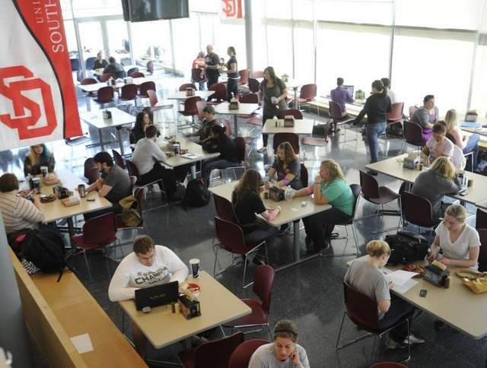USD's Muenster Center. A new study says not enough graduates of South Dakota universities are staying in state.

Written

Workforce challenges
A new study compiled for the South Dakota Board of Regents alludes to a number of challenges to the state’s labor needs in the future. Among the findings:
• The U.S. Bureau of Labor Statistics projects more than 41,000 new jobs will be created in South Dakota between 2008 and 2018.
• South Dakota’s homegrown workforce will be smaller in the next generation than it is now. In the decade ending in 2010, the number of state residents ages 10 to 14 had fallen 9.3 percent, while those 15 to 19 fell by 7.7 percent. Meanwhile, South Dakotans age 55 to 59 were up 61.3 percent, and 60 to 64 were up 51.6 percent.
• Only 25.1 percent of South Dakotans over age 24 have a bachelor’s degree or higher, ranking the state 34th among all states and below the national average of 27.9 percent.

A new study by the Board of Regents suggests South Dakota does a good job of keeping its home-grown university and college students in its workforce but needs to do a lot more to meet a looming labor shortage. Seventy percent of South Dakotans attending one of the state’s six public universities will remain here after graduation to either work or pursue more education, the study found. And further, three out of every 10 out-of-state students also will remain in South Dakota once they graduate from the public universities.
The trouble is, it’s not nearly enough. The U.S. Bureau of Labor Statistics projects that 41,000 new jobs will be created in South Dakota between 2008 and 2018, many of those in health care, finance, manufacturing, information technology, engineering, accounting and so on. But the number of young people in the state available to take those jobs is shrinking.
From 2000 to 2010, state residents age 10 to 14 dropped 9.3 percent, and those 15 to 19 fell 7.7 percent. Conversely, South Dakotans within the 55 to 59 age group grew by 61.3 percent, and those 60 to 64 were up 51.6 percent.
“What that says is, if we don’t import more young people into South Dakota and keep them, there is going to be a time not so far in the future when there will be a dramatic shift of our population into retirement age, and the workforce numbers won’t be there,” said Kathryn Johnson of Hill City, president of the state Board of Regents.
Of course the regents see the study as an affirmation that more needs to be done to help students graduate with degrees. A piece of that strategy, implemented in 2006, was to lower nonresident tuition rates to 150 percent of the in-state rate to lure more people from out of state. Johnson said that move has proven quite successful. But the regents also are talking about the possibility of rewarding the public universities financially for increasing the number of students who start on their campuses and then graduate, Johnson said. That could involve setting aside a portion of state dollars to higher education for a performance-based fund to be distributed to the universities depending on their graduation outcomes.
Asked whether they could provide enough money to make that incentive worthwhile to the schools, Johnson said, “I don’t know. That’s what we’re talking about.”
State labor officials say increasing the workforce involves more than just creating additional college graduates. While there have been great strides in technical school, community college and online programs, education has to become even more portable, said Mary Medema, director of workforce development for the Sioux Falls Development Foundation.
“Most coursework falls into the model that would lead to a degree or credits or whatever,” Medema said. “But condensed, applied learning doesn’t really seem to be available.
“I think the workplace is calling for skills upgrades and different ways to provide that. If you could take a six-hour course and obtain some level of familiarity or expertise through it without necessarily having to apply it to a degree, that’s what I think is needed.”
State Labor Secretary Pam Roberts would argue that technical schools are answering those needs. Those schools work closely with the business sectors, she said, sending trainers out to the workplace, “and are very willing to fine-tune any kind of training they need.”
As for the future of the high school graduate with no post-secondary training, Roberts and Medema said those workers still need to be open to remaining lifelong learners if they want to make a decent salary. Roberts talked about a company in Huron that is looking for quality workers, preferably individuals with skills developed at a technical school, but at the very least with a high school diploma.
“They would start at $10.50 an hour and, staying in production, would go up to $15 an hour,” Roberts said. “If you have the ability to get to work on time and you stay there long enough, they would train you right there in the workforce, and I feel confident in that situation that you would make a liveable wage.”
But the reality is, even high school graduates probably must embrace the idea of further training and education if they are going to make enough income to sustain a household or raise a family in 21st century South Dakota.
“There are jobs that do not require an education beyond high school, but they require an aptitude to learn on the job, to perform well, and to learn tasks,” Medema said. “And the assumption is, if you’ve been in some kind of learning environment after high school, you’re more adaptable to doing that.”
Of course, producing more college grads doesn’t guarantee the state will keep more people home. Tom Tolman, a sophomore at South Dakota State University, is switching his major to wildlife and fisheries. The Rapid City native would like to stay in the Black Hills if he can find opportunities. But he could see himself leaving.
“The area where I live has to have things for me to do outdoors,” Tolman said.
Aaron Peterson, a 21-year-old mechanical engineering student at SDSU from Warner, said he very much wants to see the world beyond South Dakota’s borders.
“Would I come back?” Peterson asked. “It depends on the way the world portrays itself. I guess for myself, you don’t really know where you want to spend your life until you see the rest of the world, go there, live and see what it’s like.”
That’s fine with Roberts in the labor department. See the world and come home, she said. Her department is involved with a program called Dakota Roots, which encourages residents to send out-of-state friends and family to a website that will try to match job seekers with work opportunities in South Dakota. Since it was started in late 2006, it has averaged luring one individual or family to South Dakota every single day, Roberts said. It’s efforts like that, she said, along with work by higher education institutions and workforce development groups that ultimately will meet South Dakota’s job needs.
“We have a challenge,” Roberts said. “We see the demographic challenges coming. But as a state, I think we’re staying on top of it.”
http://www.argusleader.com/article/20111223/NEWS/312230008/Study-Labor-shortage-looms-South-Dakota

