Managers to Millennials: Job interview no time to text
Paul Davidson, USA TODAY10:51 a.m. EDT April 29, 2013

Many college grads lack interview skills. They take calls, text and sometimes bring their parents or pets to interviews. HR execs blame a coddled generation weaned on smartphones and social media.
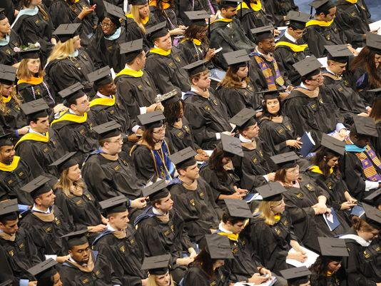Another class is graduating from college, but will they know how to conduct themselves professionally in job interviews?
Newly minted college graduates soon entering the job market could be facing another hurdle besides high unemployment and a sluggish economy. Hiring managers say many perform poorly — sometimes even bizarrely — in job interviews. Human resource professionals say they've seen recent college grads text or take calls in interviews, dress inappropriately, use slang or overly casual language and exhibit other oddball behavior.
"It's behavior that may be completely appropriate outside the interview," says Jaime Fall, vice president of the HR Policy Association. "The interview is still a traditional environment."
Fall and other HR executives say such quirks have become more commonplace the past three years or so, and are displayed by about one in five recent grads. They're prompting recruiters to rule out otherwise qualified candidates for entry-level positions and delay hiring decisions. The trend reflects a generation of Millennials — ranging in age from 18 to 34 — who grew up texting and using smartphones and social media, says Mara Swan, executive vice president of staffing firm Manpower Group.
"Life has gotten more casual," Swan says. "They don't realize (the interview) is a sales event."
So much off-the-cuff speaking in tweets and text messages has left many young people with stunted social skills, says Jonathan Singel, director of talent acquisition for Avery Dennison, a packaging and label maker.
Fall says Millennials also have been coddled by parents. "It's (a mindset of) 'You're perfect just the way are,' " he says. " 'Do whatever you're comfortable doing.' "
About half of HR executives say most recent grads are not professional their first year on the job, up from 40% of executives who had that view in 2012, according to a recent survey by the Center for Professional Excellence at York College of Pennsylvania. The HR Policy Association recently launched a website, jobipedia.org, to provide advice to first-time job seekers about interviewing, resumes and workplace behavior.
Why some job candidates flunked their interviews:
• Taking calls and texting. A male graduate student seeking a managerial position in Avery Dennison's research and development unit took a call on his smartphone about 15 minutes into the interview. The call, which lasted about a minute and wasn't an emergency, ruined his near-certain chance for a job offer, Singel says.
"If he thought that was OK, what else does he think is appropriate?" he says.
• Helicoptering parents. A man in his late 20s brought his father into a 45-minute interview for a material handling job on an assembly line, says Teri Nichols, owner of a Spherion staffing-agency in Brooksville, Fla. At Cigna, a health insurance provider, the father of a recent grad who received an offer for a sales job, called to negotiate a higher salary, says Paula Welch, a Cigna HR consultant.
• Pets in tow. A college senior brought her cat into an interview for a buyer's position at clothing retailer American Eagle. She set the crate-housed cat on the interviewer's desk and periodically played with it. "It hit me like — why would you think that's OK?" says Mark Dillon, the chain's former recruiting director. "She cut herself off before she had a chance."
http://www.usatoday.com/story/money/business/2013/04/28/college-grads-job-interviews/2113505/?utm_source=feedburner&utm_medium=feed&utm_campaign=Feed%3A+UsatodaycomMoney-Waggoner+(Money+-+Waggoner)

