Not enough workers?

Problem: S.D. employers can't find enough skilled employees. Effect: Expansion could slow and some business might leave

11:51 PM, Feb. 4, 2012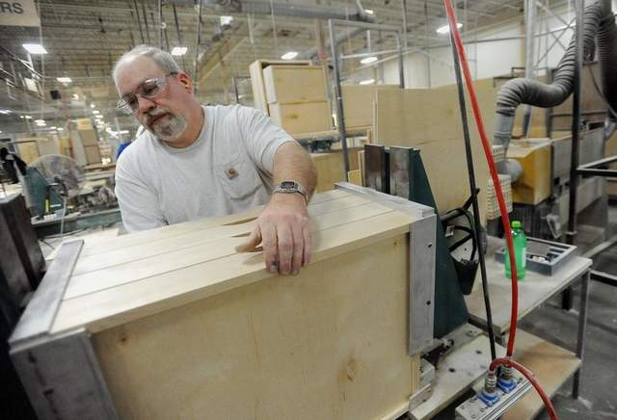

Dale Cottrill assembles a set of cabinet drawers last week at Showplace Wood Products in Harrisburg. South Dakota officials see potential for economic growth tied to developing a workforce in manufacturing. / Elisha Page /

Written by Sarah Reinecke
Manufacturing is a big part of South Dakota’s economy. And it could be even bigger, if employers could find the skilled workers they need to expand their businesses. Finding, training and retaining skilled workers is a challenge across the country, and particularly in South Dakota. Solutions are complex. But if the state wants to continue to weather a tough economy, officials say it’s time to step up and make progress or watch businesses —and their money — leave. Business expansion and job growth spurs more economic development. It provides jobs for construction workers, makes room for new businesses and circulates more money through the state economy.
Leaders say the solution includes technical education and training for young South Dakotans, attracting out-of-state workers to the state, keeping residents here and bringing back those who have left, and teaching young people that skilled trades are respectable career choices. Manufacturing has been one of the fastest-growing facets of South Dakota’s economic recovery. But low unemployment rates and a decline in rural populations are partly to blame for creating more jobs than there are qualified workers.
“South Dakota demographics show us we’re not going to have enough people here so we’re going to need to recruit those from other areas,” said Renee Storm, director of human resources at Showplace Wood Products in Harrisburg.

State ramps up recruiting efforts
Governor Daugaard policy adviser Kim Olson said state labor data show there are 1,500 openings daily in manufacturing, engineering, information technology and financial services fields. The data also show fewer than 100 people receiving unemployment in those fields.
Hisel was among organizers of a regional workforce summit in November in Mitchell. He said the James River Basin has more than 550 job openings in manufacturing and production fields and expects to have 2,000 openings the next two years.
Trail King started working with a Wisconsin-based recruiting agency that specializes in welders last fall, and Yakley said so far, “we’re hitting a home run with it.” He needs 100 workers in Mitchell, another 100 in Fargo, and anticipates hiring 500 workers between both locations during the next three years. So far, Yakley said he’s brought workers here from states such as Texas, Florida, Virginia and Ohio.
Tracey Deatherage, recruiting manager for Daktronics, said the company has about 50 openings, mostly in engineering and manufacturing. Daktronics advertises on various job boards and uses the South Dakota Department of Labor to find candidates in similar climates.
“We have way more jobs available for technically skilled individuals than what we actually have a supply of here in the state, so we really have to do a good job of drawing people to our state,” she said.

Shift to modern manufacturing
Many students graduate high school and opt for four-year colleges or universities instead of training for blue collar work. That’s a concern for Ed Thompson, 52, who’s been working at Trail King since 1982. Thompson started as a welder on the factory floor and worked his way up, becoming director of manufacturing in 2004. He now oversees 260 workers. Each job came with a pay raise, and Thompson said manufacturers such as Trail King have a lot to offer people looking for steady careers.
“Manufacturing is not a dark, dingy environment. There are good salaries paid out,” he said, adding that as Trail King expands, more opportunities for leadership roles will be made available.
Thompson said the 270,000-square-foot plant is “very bright. It’s clean and organized. We have all kinds of lifting devices, so you don’t have to lift and be worn out by the end of the day.”
Tom Bohnet, president of Applied Engineering in Yankton, said the 180-person company has had a difficult time finding workers with the precision machining skills and other highly technical skills. Applied Engineering posts jobs online, in newspapers, has traveled schools from Minnesota to Iowa, Nebraska and South Dakota, and opens the facility for tours to pique interest of area students and parents. Still, Bohnet said positions are open for months at a time.
“We’re reaching the point where we have to do something on a more national level of trying to bring people to the state,” he said. “We have to do something different if we want to continue to grow, we have to get people to move to our part of the world.”

The numbers
4.2 percent: South Dakota jobless rate in December
8.3 percent: Nationwide unemployment rate in January
38,000: Manufacturing jobs in South Dakota in December
2.4 percent: Increase in manufacturing jobs from December 2010 to 2011.
58: Percentage of 250 companies state representatives have talked with that say they’ll add workers.

Top jobs
South Dakota’s top manufacturing companies:
3M Co., Aberdeen and Brookings
Adams Thermal Systems, Canton
Angus Palm Industries, Watertown
Dakota Provisions, Huron
Daktronics, Brookings and Sioux Falls
Interbake Foods, North Sioux City
John Morrell & Co., Sioux Falls
Larson Manufacturing, Brookings
LSI, Alpena
Molded Fiberglas, Aberdeen
Raven Industries, Sioux Falls
Starmark Cos., Sioux Falls
Trail King Industries, Mitchell
Source: Quarterly Census of Employment and Wages data, Bureau of Labor Statistics, U.S. Department of Labor, third quarter 2011 employment data.
http://www.argusleader.com/article/20120205/NEWS/302050019/Not-enough-workers-

