Wright or wrong, tweets cost HS football player a college scholarship
SHEMAR WOODS
Friday, January 20, 2012
All indications pointed to Yuri Wright attending Michigan this fall to play football for the Wolverines. But following a landmark decision, the four-star recruit's college future hangs in the balance.
Wright, ranked 85th among the country's high school football propects, was expelled from Don Bosco Prep School on Wednesday for sexually graphic and racial tweets posted to his personal Twitter account followed by more than 1,500 accounts. Michigan backed the prep school's decision by rescinding Wright's scholarship, according to multiple reports.
http://articles.nydailynews.com/2012-01-20/news/30649266_1_college-scholarship-tweets-notre-dame-and-michigan

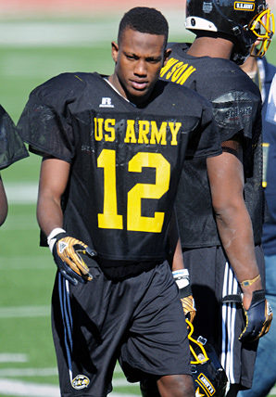
Four-star cornerback Yuri Wright was expelled from Don Bosco Prep (N.J.) over a series of ill-advised comments on his Twitter feed.
Read more: http://sportsillustrated.cnn.com/2012/writers/andy_staples/01/24/recruits.social.media/index.html#ixzz1l3fK6FNC

Updated: January 26, 2012, 3:01 AM ET

Yuri Wright commits to Colorado
By Dave Hooker
Cornerback Yuri Wright, the 40th-ranked player on the ESPNU 150, has committed to Colorado, his former high school coach confirmed Tuesday. Wright was kicked out of Don Bosco Prep in Ramsey, N.J., Jan. 18 after sexually graphic and racial posts on his Twitter account came to light.
"This is a positive thing. Definitely a huge positive going to Colorado," Don Bosco coach Greg Toal told ESPNNewYork.com. "... This is an opportunity for him to resurrect his life in a lot of ways and a good opportunity to be successful at the next level."
Among the other schools from which he had scholarship offers were Rutgers, Notre Dame and Michigan. A number of media outlets reported that Michigan stopped recruiting him when news of the Twitter posts broke. Wright had taken an official visit to Colorado in December, the Newark Star-Ledger reported.
National signing day is Feb. 1.
Don Bosco sophomore running back Jabrill Peppers said he tried to warn Wright about the dangers of posting on social media sites, but was happy that Colorado "stuck with him."
"I said, 'You got to watch what you put on the Internet. If you think it can be looked at as a negative, it shouldn't be out there. I told him and he made his own choices,' " Peppers told ESPNNewYork.com. "It wasn't the smartest decision. But he's just a high schooler, he's not a man yet, he's still growing. We make mistakes."
Wright has a new Twitter account, according to The Record (Bergen, N.J.).
Wright, a 6-foot-1, 185-pound senior, is ranked the fourth-best high school cornerback prospect in the country. Wright played in the U.S. Army All-American Bowl in San Antonio earlier this month. Toal said last week that he had received calls from a few coaches regarding the situation, and believed Wright ultimately will weather the situation.
http://espn.go.com/new-york/story/_/id/7498273/ex-don-bosco-player-yuri-wright-commits-colorado-buffaloes

