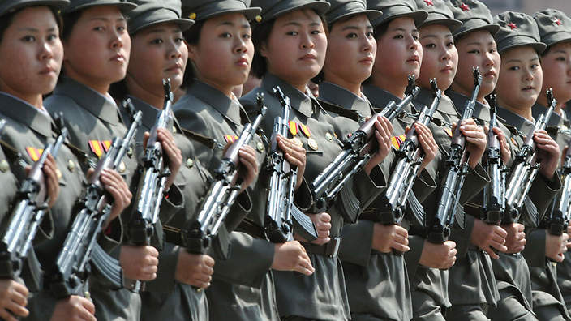

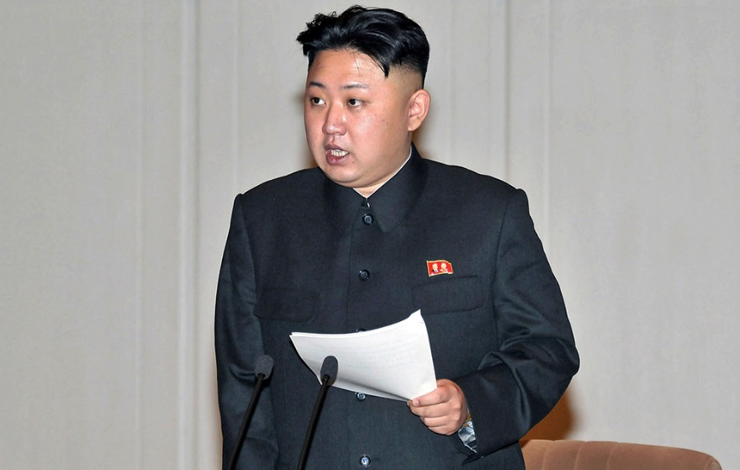North Korean leader Kim Jong Un

American Was Caught And Imprisoned In North Korea For Spreading Christianity
By Michelle FlorCruz November 15 2013 3:43 PM
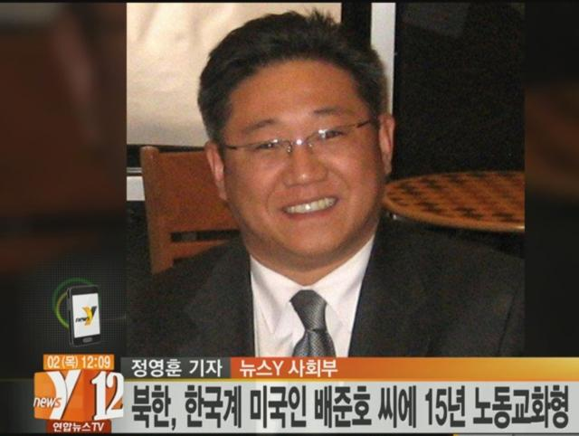 An undated still image from video footage shows U.S. citizen Kenneth Bae.
Getting access to North Korea is already quite difficult. Still, a group of Christian missionaries have been able to make some inroads into the isolated nation by pretending to be visiting businessmen seeking trade opportunities. According to a report by the Telegraph, a detained American citizen, 44-year old Kenneth Bae, was one of several people working covertly as missionaries while also operating as tour guides, bringing in groups of people to the Wongjong border crossing between China and North Korea.
Bae was working under the auspices of a tourism company called Nations Tour when he was arrested in November 2012 and eventually convicted of committing “hostile acts” against North Korea. He is currently serving a 15-year sentence at a labor camp. While details concerning what specifically triggered Bae’s arrest remain unclear, his religious affiliations were likely one of the major reasons why he was caught.
As with other information from North Korea, it is hard to verify just how many business operations are functioning as fronts for people seeking to evangelize in the country. While there is a misconception that all organized religion is banned in the oppressive state, Buddhism and Cheondoism, a Korean religion that has a corresponding political party representing it, can be practiced in the country. Christianity, on the other hand, continues to be prohibited because of its association with the West. North Korea’s government has relentlessly suppressed practice of the faith, and defectors have alleged that the mere possession of a Bible was reason enough to be arrested.
Still, according to the Telegraph report, one unidentified American who had been on a tour with Bae in the past says that in the Special Economic Zone outside the city of Rason where they entered, officials turned a blind eye to them when they brought in Christian Bibles. Because North Korea is strapped for money, food, fuel and other resources, officials in the zone were more lenient. The Bibles that were brought into the country were meticulously counted at the border, and counted again upon departure, the source said, to ensure that no religious texts were distributed.
While inside the borders of North Korea, the group would sing Christian songs, but hum some verses of the tune to avoid uttering the word “God” aloud. “That was our way of worshipping and praising in our hearts, even if we could not say it,” the source said in the report. “Talking about God directly, that would be asking for a death sentence.”
Although the group did not overtly emphasize that they were engaged in a Christian mission, their public worship was designed to allow for the “walls” to come down in North Korea and to call for “the leadership to allow more freedom for their people to freely worship if they want to.”
Moreover, Bae’s training at religious centers in the United States suggests that he was in North Korea to help spread Christianity among the people. Bae was reportedly working with the Youth with a Mission (YWAM), a global ministry based in Hawaii. According to Loren Cunningham, the founder of YWAM, smuggling Bibles into North Korea was one of their principal goals. YWAM believes that the Christian gospel will sustain morality within the nation under the oppressive regime of Kim Jong-un.
According to a report in Christian Today Australia, which explicitly described Bae as a “Christian missionary,” Bae is now the “longest serving American prisoner in North Korea since Korean War,” after a year in detention.
http://www.ibtimes.com/kenneth-bae-american-was-caught-imprisoned-north-korea-spreading-christianity-1472902

Capitalism in N. Korea: Professor Andrei Lankov Mentions Capitalism Emerging in North Korea
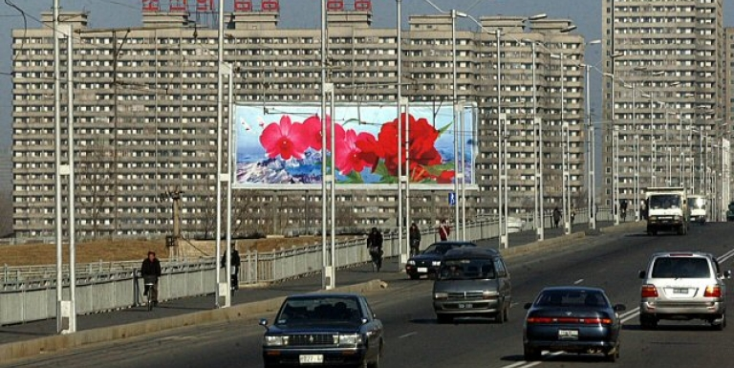
The upper class in Pyongyang drive their own cars and pay huge sums of money to eat out in fancy restaurants downtown.
18 November 2013
Kookmin University professor Andrei Lankov contributed an article to US-based NK News on November 14,saying that North Korea is witnessing the formation of the bourgeoisie and the newly rich. He mentioned in the article, “Pyongyang appears to be maintaining the Stalinist concept of socialism these days, but its government officials are seeing the private economy emerging there to cause a wealth divide.” In short, it is showing some signs of significant wealth inequality amid the early stages of capitalism. “Most of the North Korean population are still stricken with poverty but there are some better-off people, including non-officials and middle-class entrepreneurs, who own hundreds of thousands of dollars,” he added.
Until as recently as the mid-1990s, most of the upper class in North Korea were party officers and government officials. They hid their assets effectively and thus others could not notice how wealthy a life they lived. However, according to the professor’s remarks, all of the people are well aware of the fact that they drive their own cars and pay huge sums of money to eat out in fancy restaurants in downtown Pyongyang.
He continued to explain that he has pretty good evidence of this point, although there are no statistics for now about who newly rich and what their income sources are. “It seems that many of the nouveau riche have gathered wealth through bribery and collusion while running state-owned companies, or made a sizable fortune during or right after the severe famine in the 1990s,” he said, adding, “As of now, those with a monthly income of US$300 to US$400 or higher are considered rich, and very rich if the amount exceeds thousands of dollars.”
In North Korea, air conditioners, refrigerators, washing machines, and the like are regarded as luxury items. These are rarely in use in reality but just exhibited in most cases, due to the high frequency of power outages. Many upper-class people have LCD TVs, electric cookers, and furniture imported from China, too. Self-owned cars are owned by top 0.1% of the population, and most of these are in the name of national organizations to prevent any problem from arising. Traveling not just at home but abroad is very limited even for the wealthy class, though.
“Real estate transactions have begun to be made between rich people, though illegal, and a high-rise apartment house is currently purchasable at US$10,000 to US$25,000 in a small town and between US$50,000 and US$80,000 in Pyongyang,” he continued, declaring that Leninism is done in the North.
“Over time, the private market in North Korea will become a space where rumors concerning the external world are freely circulating, and the population will be less and less dependent on rationing for their livelihood if capitalism is in progress there,” he explained, adding, “This will be of no good to the Kim Jong-un regime, but the key officials and the wealthy class are in the same boat when it comes to the gradual change in the economic system.”
http://www.businesskorea.co.kr/article/2213/capitalism-n-korea-professor-andrei-lankov-mentions-capitalism-emerging-north-korea#sthash.Qmzpu8FB.dpuf

US N. Korea Envoy in Asia Amid Push to Revive Nuclear Talks
by William Ide November 18, 2013

The United States special envoy to North Korea travels to Asia this week as regional powers step up efforts to restart talks on ending Pyongyang’s nuclear weapons programs. Glyn Davies, the U.S. Special Representative for North Korea arrives in China Tuesday and will later make stops in Seoul and Tokyo. But it is the envoy’s stop in China that is going to be watched closely for any signs of a breakthrough.
When Glyn Davies arrives in Beijing Tuesday it will be the second time he has met with China’s top negotiator, Wu Dawei, in the short space of less than a month. Wu has been traveling between Pyongyang and Washington in recent weeks. Japan, South Korea and the United States have also held trilateral talks in Washington.
The U.S. State Department was hesitant to make any predictions about the talks when Davies’ travel plans were released last week, but did add that “every discussion is an opportunity.”
North Korea analysts in China agree.
“It’s very difficult to tell what exactly will come out of Glyn Davies' visit this time. But the fact that Davies is coming shows that both China and the United States are working very closely to bring North Korea back to the diplomatic track,” said Wang Dong, a political scientist at Peking University.
North Korea pulled out of the six party-talks in 2009 and has called for their resumption with no preconditions. Washington says North Korea needs to show it is serious about abandoning its pursuit of nuclear weapons before the United States will resume negotiations. For its part, China has been stepping up its efforts in recent months to let the North know how serious it is about sanctions and getting back to the negotiating table.
In September, China released a list of banned export items to North Korea to make sure that United Nations sanctions were being tightly enforced following a North Korean nuclear test earlier this year. The list was released amid reported concerns that North Korea might be accelerating its nuclear weapons programs. At the same time, however, North Korea has been accelerating its efforts to boost economic engagement as well, particularly with China.
China is North Korea’s biggest trading partner and Beijing is keen to get Pyongyang to adopt more economic openness. Analysts say the hope is that such advances would gradually shake the North of its nuclear ambitions.
Lu Chao, a specialist on the Korean peninsula at Liaoning Academy of Social Sciences, says China’s influence, however, is limited. Lu says that ultimately North Korea will decide whether it opens up or not. He says China wants to see more businessmen going there to invest, but from the North’s perspective it seems that Pyongyang will not open up too quickly or broadly to reform. Adding that it is still a military first regime.
Wang Dong says what the international community needs is a peaceful development strategy for North Korea to help it move beyond its insecurities and ideological constraints that keep it from developing its economy.
“North Korea has to understand the logic that they cannot eat the cake and have it too. I think this is very important. They say they want economic construction and they say they also want nuclear capability, but they have to understand there are trade-offs between the two,” said Wang Dong.
Earlier this fall, the North proposed a freeze of its nuclear and long-range ballistic missile tests in exchange for the restart of talks. The offer, while viewed by the U.S. government as a positive step, has failed to gain any traction. Pyongyang has made similar promises in the past, only to go back on them.

http://www.voanews.com/content/us-north-korea-envoy-in-asia-amid-push-to-revive-nuclear-talks/1792218.html

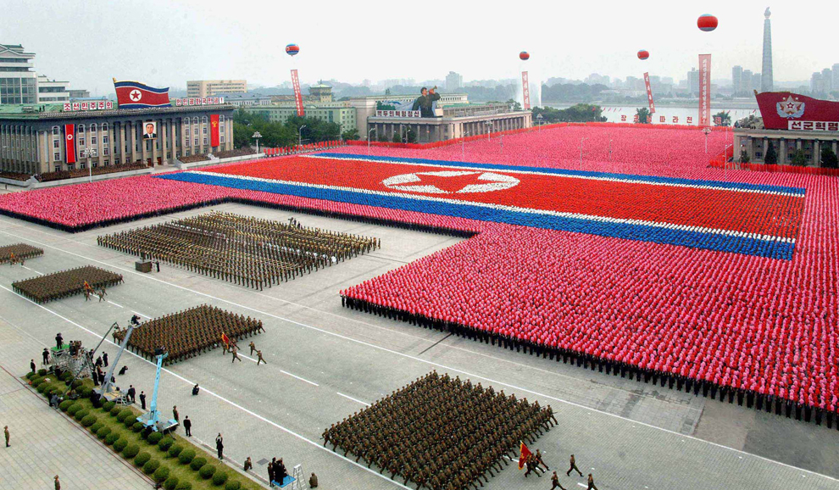

North Korean defectors tell their stories

By Yaara Bou Melhem 19 Nov 2013
Most people who escape North Korea leave family and friends behind, and it’s concern for them that forces many to remain silent. North Korea has a harsh system of inferred criminality across generations. It means a son, daughter, sister, brother or grandchild speaking out could lead to up to three generations of a family being punished.
This fear has bound Park Ji Yung, one of the witnesses who came forward to testify at the UN Inquiry, for the better part of her last five years in the United Kingdom. Only recently has she begun to publicly speak out about human rights and women’s issues in North Korea and China.
Most of Park’s family have fled North Korea or have already died. She was forced to leave her dying father and is unsure about the wellbeing of a brother, who she believes at best is in prison or at worst died while in captivity.
She was sold into marriage after first fleeing from North Korea to China, but is now finally making a new life for herself and her family in the north of England. Park’s second husband is also a North Korean defector. He still has family in North Korea so is mindful of concealing his identity. He is proud of his wife’s courage to speak out about the horrors she endured. He told me if he too could afford to go public he would, but there’s too much personally at stake.
"This is the only way human rights in North Korea will improve," Ji Yung tells me. "Just because we’re happy now, and try to forget our past, even though it’s not something you can forget, there will be more women involved in human trafficking and more children who have to go through this pain."
But they are grateful to be out and able to raise their children in the relative safety and security of the UK. I don't think the children fully comprehend yet though. They ask why they don't have family around they can visit at Christmas and Easter like the other kids at school do. What do you say to that?
North Korea remains one of the world’s most tightly controlled and censored countries in the world, restricting international media access to the country and feeding information to its own citizens mostly through the government’s official news agency. Another of the witnesses at the UN Inquiry, Kim Joo-il, wants to change that. The former North Korean soldier and Chairman of the North Korea Residents Association of the UK has set up the ‘Free NK’ newspaper.
“We want the people of North Korea to realise that their human rights are being violated,” he tells me at his small office in Surrey.
While his website is blocked in North Korea, he says he knows smuggling routes that he aims to use to take his newspaper into his homeland. It may seem dangerous but Joo-il says it’s his way of trying to counter the narrative from the North Korean capital, Pyongyang. He’s lost hope in the international community coming to the rescue of North Korea, saying three generations of autocratic rule in his country support that view.
Joo-il says change will only come from North Koreans themselves.
“We want people to become advocates of their own rights. It is risky and dangerous but I believe it is something that needs to be done. If this can bring change to the North Korean community then the risk is worth it. “
http://www.sbs.com.au/news/article/2013/11/19/north-korean-defectors-tell-their-stories

