Africa’s Quiet Resurgence
SEPTEMBER 19, 2011
It's still the world's most troubled continent, but a New York Times columnist finds signs of a turnaround
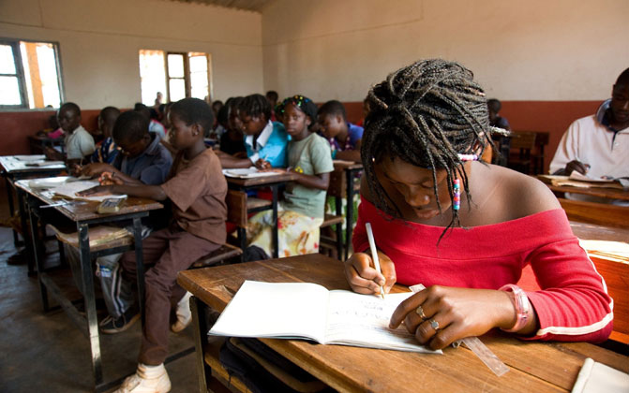All across Africa, girls are more likely to go to school than a decade ago.
BY NICHOLAS D. KRISTOF | FOR THE NEW YORK TIMES UPFRONT MAGAZINE
One of the best-kept secrets in the world today can be found in thatched-roof villages in countries across Africa: This long-struggling continent appears to be turning around. After a half-century of underperformance, Africa's economy is growing significantly faster than America's or Europe's. In the last decade, 6 of the 10 fastest-growing economies in the world were in sub-Saharan Africa, and that proportion is expected to rise even higher in the next five years. The global economy has turned upside down: Europe and the U.S. are in terrible shape, while much of Africa is booming.
This trend was obvious on my recent trip to five African countries. It was the fifth "win-a-trip contest," in which I take a student on a reporting trip to the developing world. This year, there were two winners: Saumya Dave, a medical student from Atlanta and Noreen Connolly, a journalism teacher at a Catholic school in Newark, New Jersey.
The journey began in Morocco, which is a window into one of the most striking trends in Africa: democratization. The number of electoral democracies in Africa has risen to 18 from 4 in the last decade, according to Freedom House, a human rights organization in Washington, D.C. Morocco is still a repressive monarchy, but things are improving. For example, it has freed some political prisoners and strengthened its parliament.
From there, we headed to Nouakchott (NO-AAK-SHOT), the sleepy capital of Mauritania, where we got a lesson in one of the most cost-effective interventions to save lives: food fortification—adding vitamins and minerals to food staples. Mauritania's biggest flour mill, which supplies 45 percent of the nation's flour, has begun adding iron, zinc, folic acid, and vitamin B12 to its flour—at an added cost of just one penny for six loaves.
American foreign aid money helped pay the start-up cost of fortification, which may save more lives by preventing malnutrition than a hospital could save. In the United States, there's recently been a backlash against such humanitarian aid. Some argue that instead of helping people, aid encourages dependence and feeds corruption. But because of initiatives like food fortification—and vaccinations—child mortality is tumbling in the developing world. In 1990, 12.4 million children died annually before age 5, according to the World Health Organization. By 2009, despite a significantly larger population, the toll had dropped to 8.1 million.
MEASLES & RIVER BLINDNESS
Next we visited Niger (NEE-ZHAIR), one of the poorest countries in the world. In a remote town near the Nigerian border, we saw what doctors call severe acute malnutrition.
A 2-year-old child, Alou Muhammad, was lying nearly comatose in the local hospital, his ribs protruding, receiving fluid from an IV drip. Alou's left eye had Bitot's spots—signs of vitamin A deficiency that leads to blindness. At least 250,000 children go blind each year for lack of vitamin A, and half of them die within a year of going blind. Alou had gotten measles and gone downhill from there. Yet there was a silver lining: This was the first measles case that the head doctor had seen since arriving at the hospital seven months earlier—and Alou actually came from across the border in Nigeria.
Children in Niger now routinely are vaccinated for measles and also get vitamin A drops to prevent blindness and death. So even though Niger is one of the world's poorest countries, it has figured out how to deliver these services—while Nigeria, much richer, still allows children like Alou to catch measles.
"If Niger can make progress, anybody can," says Shawn Baker of Helen Keller International, an aid group. When I first backpacked through West Africa in 1982, what I found most wrenching were the ubiquitous blind beggars, victims of a disease called river blindness, spread by the bites of black flies. The flies carry parasites that grow into worms whose offspring eat away at the optic nerve and cause severe itching, excruciating pain, and blindness.
"This was more painful than childbirth," said Fatouma Oumarou, a 70-year-old woman who had gone blind from the ailment. At the peak of the disease, she recalled, much of the land in the area was left fallow because farmers did not dare work there. Indeed, villagers say they were more afraid of black flies than lions.
These days river blindness is gone from this region, thanks partly to work by the Carter Center, run by former President Jimmy Carter, and to vast contributions of medicine by Merck, the pharmaceutical company.
AIDS still takes a huge toll—1.8 million Africans became infected with H.I.V. in 2009—but we saw progress. In Burkina Faso, we visited women who received drugs during labor that significantly reduce the risk of mother-to-child transmission. It's a cheap, simple intervention that avoids the need for lifelong medication for the child.
"There is unprecedented progress in global health," says Michel Kazatchkine, executive director of the Global Fund to Fight AIDS, Tuberculosis, and Malaria. "Things that we would have seen as a dream in 2001 now are achievable objectives: a world of almost no malaria deaths, a world with almost no mother-to-child transmission of H.I.V."
SOLAR PANELS & CELLPHONES
We often stopped in villages and asked about education. We did run into children who didn't go to school at all. But that's becoming rare, and girls in particular are more likely to attend school now than they were a decade ago. The United Nations says that primary-school enrollment in sub-Saharan Africa has increased five times as quickly since 1999 as it did in the previous decade.
Everywhere, we saw how technology is transforming lives. A generation ago, many in the countryside had to collect water from mud puddles; now they have covered wells with clean water.
We saw solar panels used to power electric lights. Roads are improving, and motorcycles and trucks are more common. One result is that when a mother is in difficult or life-threatening labor, she can now sometimes be taken to a hospital in the back of a pickup truck instead of rolled there in a wheelbarrow.
But the grandest new technology is the cellphone. "More than 100 people here have cellphones," one woman told us proudly in her village in Burkina Faso. "There are too many to count." We asked how many toilets the village had, and she explained that not a single home had yet installed an outhouse. Why would people prioritize cellphones over toilets? With cellphones, families can find out which market town offers the best price for their goods, or where fertilizer is cheapest. And they can find out where there are jobs.
Huge obstacles remain. One we saw firsthand was Africa's corruption and stifling bureaucracy. Crossing the border from Mauritania to Senegal, we saw trucks that had been waiting for a month to cross—because of a dispute between officials on each side. At the Niger-Burkina Faso border, we again saw lines of trucks waiting for customs inspections (which often means bribes to officials to avoid an inspection).
Africa is still riven by horrible civil wars and deep ethnic conflicts. Across West Africa, Al Qaeda is becoming more powerful, adding to the terrorist threat. African leaders need to promote trade, simplify border crossings, reduce graft, and encourage homegrown private business. They also need to do a better job of solving the continent's bloody conflicts.
The poverty in Africa is heartbreaking, and the lack of security is a real problem. But overall, it's a continent that's chipping away at poverty and disease, while doing a better job of educating its young. Africa seems likely to become a much more important part of the global economy in the 21st century—a place to admire, not to pity.

http://upfront.scholastic.com/news/2011/09/africa-s-quiet-resurgence

- List 9 recent improvements in Africa.
A)

B)

C)

D)

E)

F)

G)

H)

I)

- List 8 existing problems in Africa.
A)

B)

C)

D)

E)

F)

G)

H)

- List 4 reasons why improvements are being made in Africa.

A)

B)

C)

D)

