Indian waste workers fear loss of income from trash-to-electricity projects

By Rama Lakshmi November 20, 2011
In New Delhi — For five hours every day, Ranjit Kumar and his 10-year-old son rummage through a giant pile of rotting trash with their bare hands, filling bags with pieces of metal, plastic and glass to take by cart to the recyclers market nearby. But an incinerator under construction not far away may mean that he and other waste workers will lose access to the trash, he said, which fetches his family a little more than $5 a day.
The incinerator is one of two projects in New Delhi aimed at turning the city’s trash into electricity and earning carbon credits under the Kyoto Protocol, the global climate pact designed to reduce greenhouse-gas emissions. Local politicians have hailed the projects for addressing the city’s chronic problems of excess untreated waste and a shortage of electric power. But for almost 300,000 workers in the city engaged in waste collection, sorting and recycling, the plants mean the loss of their livelihood.
“If all the trash goes to the plants to be processed, how do we feed our stomachs?” Kumar said as foul-smelling fumes rose from the trash and dark-brown water trickled past him. “My work may look dirty, but it keeps my family alive.”
A worldwide campaign
Waste-worker communities have mobilized in Brazil, Colombia, South Africa and India to campaign on behalf of trash dumps and the livelihoods they provide, and against the idea of burning waste. The United Nations, however, has been encouraging incinerator projects that burn waste — rotting trash produces the potent greenhouse gas methane — to produce energy. Under the Kyoto Protocol, nations can earn carbon credits for such projects; the credits can be used to offset the emissions of coal-fired power plants elsewhere.
This month, hundreds of waste workers gathered outside the U.N. office in New Delhi to protest 21 municipal waste projects for which India has applied for carbon credit. The projects, not all completed, use biodegradable, combustible and inert waste. They include trash-to-compost, incinerators and refuse-derived fuel. Waste-worker groups appealed to climate negotiators when they met in Mexico, Germany and China in the past year, and they are preparing to protest at the climate meeting in Durban, South Africa, set to begin next week.
Waste workers want access to the United Nations’ $30 billion Green Climate Fund — the effort by developed countries to help the developing world prepare for climate change — for their role in mitigating climate change by recovering recyclable materials from waste. But advocates of the trash-to-energy projects say that India’s growing population, changing consumption patterns and urban boom have created a waste problem that must be addressed in a scientific manner.
“It is not an us-versus-them situation. We must frame the debate differently. Do we want the ragpickers to continue working in inhuman, hell-on-Earth, unhygienic conditions at these untreated dump sites? Should their sons and daughters do the same, too?” asked Mahesh Babu, chief executive of IL&FS Ecosmart, which heads several trash-to-energy projects across India, including the incinerator near Kumar’s neighborhood. “The solution lies in integrating some of the waste-workers into the processing activities of the plants.”
But India has a staggering 1.7 million waste workers, and any effort to mainstream them is often just a drop. Babu’s project in the central city of Nagpur has given jobs to 70 people to collect trash, out of a total of 1,700 waste workers in the city.
“The waste pickers are at the lowest rung of the occupational ladder and often the most marginalized, hence they do not have alternative livelihood options to which they can move,” Prema Gera, assistant country director of the U.N. Development Program, said in an e-mail, referring to a study.
Bhojahari Paramni, 41, has worked with waste for 25 years. He removes dirt and twigs from balls of human hair in his home in a large slum of waste workers.
“You cannot take away my job and expect me to become a successful electrician, plumber or mason overnight,” he said. There is no regulatory protection for waste workers in India.
Waste workers say that 80 percent of Indian trash is wet, organic waste and that 30 percent contains recyclable material.
“To run an incinerator, they will burn everything, including the recyclables like plastics. Is that good for the environment?” asked Shashi Bhushan Pandit, secretary of the All India Waste Workers Union. This year, New Delhi residents protested another new incinerator because they feared emissions of dioxin and other toxic gases.
Two Indian waste workers will represent their country at next week’s protest in Durban, which will demand that poor people be factored in climate policies.
http://www.washingtonpost.com/national/health-science/indian-waste-workers-fear-loss-of-income-from-trash-to-electricity-projects/2011/11/18/gIQACCB7fN_story.html?tid=pm_national_pop
Disposable Communities? Living and Working in the World's Largest Trash Dumps
September 12, 2011
It may not be treasure per se, it is still a steady income. In an effort to eke out a day’s wage, workers in many parts of the world collect and sort the refuse of others. Many of these workers are women and children.
The World Bank estimates that 1 percent of the urban population in developing countries earns a living through this work. These workers play a valuable role in many cash-strapped nations, serving as a cheap means of recycling. But working conditions are hazardous, and the dumping of medical waste poses an enormous threat to human health.
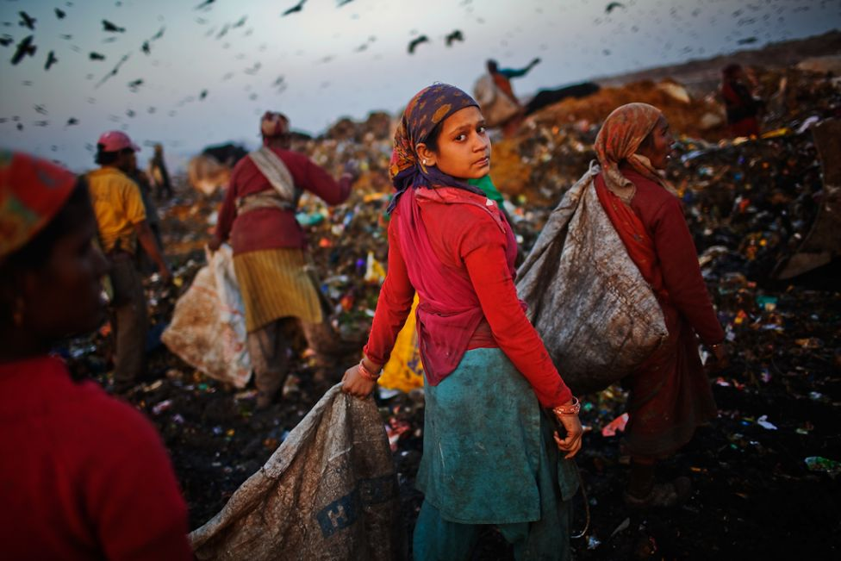
An Indian worker carries a bag of recyclable materials to sell from the 70 acre Ghazipur Landfill Site on February 18, 2010 in east Delhi, India. The estimated number of rag-pickers in Delhi is believed to be the range of 80,000 to 100,000.

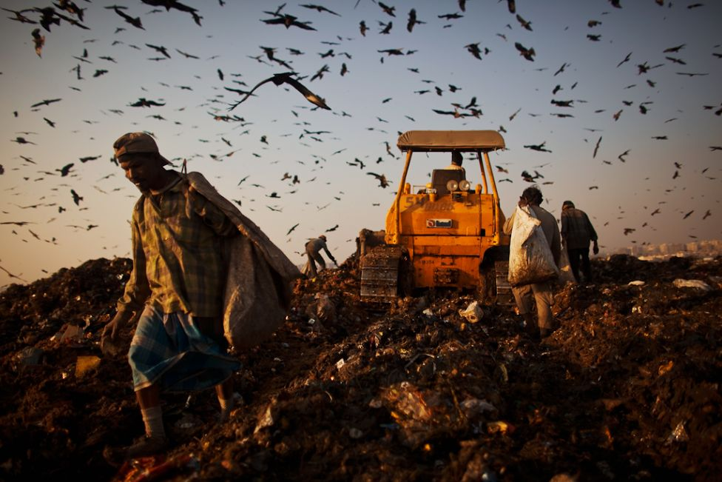
Indian workers sort through garbage at the 70 acre Ghazipur Landfill Site on February 18, 2010 in east Delhi, India.

Indian workers sort through garbage and pick out recyclable materials to sell from the 70 acre Ghazipur Landfill Site, February 18, 2010 in east Delhi, India. A wide range of materials and items are involved, such as, paper, cardboard, plastics, metals, glass, rubber, leather, textiles and clothing etc.

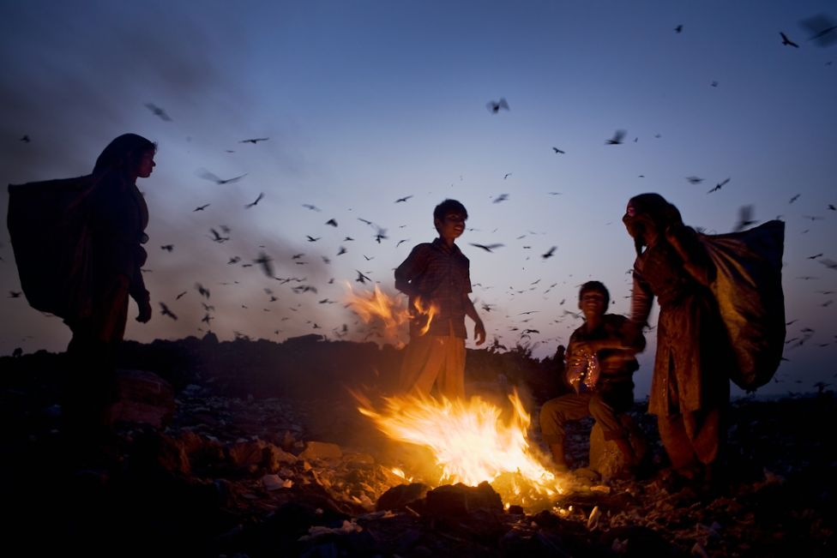
Indian workers talk amongst themselves after having sorted through garbage to collect recyclable materials to sell from the 70 acre Ghazipur Landfill Site on February 18, 2010 in east Delhi, India.

http://www.globalpost.com/photo-galleries/planet-pic/5674706/disposable-communities-living-and-working-the-worlds-largest-trash-dumps

