Iran says could deploy navy near U.S. coast
TEHRAN | Tue Sep 27, 2011 (Reuters) - Iran raised the prospect on Tuesday of sending military ships close to the United States' Atlantic coast, in what would be a major escalation of tensions between the long-standing adversaries.
"Like the arrogant powers that are present near our marine borders, we will also have a powerful presence close to American marine borders," the head of the Navy, Rear Admiral Habibollah Sayyari said, according to the official IRNA news agency.
Speaking at a ceremony marking the 31st anniversary of the start of the 1980-1988 war with Iraq, Sayyari gave no details of when such a deployment could happen or the number or type of vessels to be used.
The declaration comes just weeks after Turkey said it would host a NATO early warning radar system which will help spot missile threats from outside Europe, including potentially from Iran. The decision has angered Tehran which had enjoyed close relations with Ankara.
And it comes a few months after Iran sent warships through the Suez canal, after the fall of former Egyptian President Hosni Mubarak, the first time the Islamic Republic had deployed navy vessels in the Mediterranean.
The United States and Israel have not ruled out military action against Iran if diplomacy fails to stop it getting nuclear weapons. Tehran denies it is developing nuclear arms saying its atomic programme is for purely peaceful purposes.
Iran has dismissed the threats, warning that it will respond by hitting U.S. interests in the Gulf and Israel if any such attack happened.
Analysts say Tehran could retaliate by launching hit-and-run strikes in the Gulf and by closing the Strait of Hormuz, the waterway where about 40 percent of all traded oil passes.
The Islamic state often launches military drills in the country to display its military capabilities amid persistent speculation about a possible U.S. or Israeli strike on Iran's nuclear facilities.
(Writing by Hashem Kalantari; Editing by Rosalind Russell)
http://in.reuters.com/article/2011/09/27/idINIndia-59578420110927

Iran claims freed US hikers’ comments contrary to reality
Location: | Tehran, Iran | Published: | September 27, 2011 06:27 am EDT
Less than a week after being released from an Iranian prison, two U.S. hikers Shane Bauer and Josh Fattal accused Iran of using them as hostages in their revenge with the West – a claim strongly rejected by Tehran.
Iran's prosecutor-general Gholam Hossein Mohseni Ejeie claims that the two hikers’ comments are contrary to reality. "We had foreseen them saying so, and regardless of when we released them they would have said such things against Iran," Iran's prosecutor-general Gholam Hossein Mohseni Ejeie said.
Iranian authorities had released Bauer and Fattal last Wednesday after keeping them two years in prison on suspicion of illegal entry and spying.

Both 29-year-old men were arrested with a third American named Sarah Shourd near Iraq border on July 31, 2009. The three had always claimed that they mistakenly crossed the border into Iran. The Islamic republic had released 33-year-old Shourd last year after the Gulf state of Oman agreed to pay the bail amount of $500,000. Oman also reportedly paid $400,000 bail for the other two men.
Read more: http://www.allheadlinenews.com/articles/90061361?Iran%20claims%20freed%20US%20hikers%26%23146%3B%20comments%20contrary%20to%20reality#ixzz1ZAjwMIdW

Ahmadinejad says Iran, Sudan are allies against 'powers of arrogance'
By Isma'il Kushkush September 26, 2011
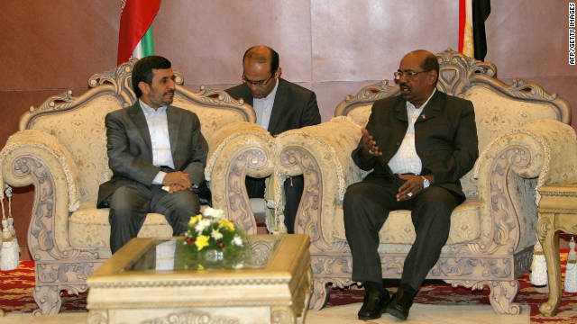
Iranian President Mahmoud Ahmadinejad (L) meets with Sudanese President Omar al-Bashir in the capital Khartoum during his official visit on September 26.
STORY HIGHLIGHTS
- Mahmoud Ahmadinejad visits Khartoum and speaks to supporters
- The Iranian presidents was traveling home after speaking at the U.N. in New York
- He tells the Sudanese that Europe and the U.S. "stole the riches of Africa"
- Sudan's Omar al-Bashir supports Iran's nuclear program "for peaceful purposes"
Khartoum, Sudan (CNN) -- Iranian President Mahmoud Ahmadinejad lashed out Monday at "the powers of arrogance," saying that both Sudan and Iran were subject to "pressures" from the West because of their political positions.

"They pressure Sudan and Iran; why? Because we stand against the powers of arrogance," Ahmadinejad said during a visit to Khartoum.

Speaking to a crowd of cheering youths, students and supporters in Khartoum's Friendship Hall, Ahmadinejad criticized Europe and the United States for what he described as the "stealing" of Africa's wealth.

"They stole the riches of Africa," he said. "Despite this wealth, we see poverty and deprivation."

Ahmadinejad arrived in Khartoum Monday morning on his way back to Iran after speaking to the United Nations General Assembly in New York, and after a brief stop in Mauritania. Western delegates walked out of his speech at the U.N.after he repeatedly condemned the United States and said some countries use the Holocaust as an "excuse to pay ransom... to Zionists."

"They don't want to see Sudan strong so they pressured it into a referendum," he said, in reference to the South Sudan referendum that led to the independence of South Sudan last July.
"Could there be a referendum in Europe, in the Basque (region of Spain) and other areas?" he asked. "I am sure if there was a neutral referendum in the U.S., some states would secede from the U.S.," he continued. "The waves of consciences have started especially in the Muslim lands," he said, in reference to the popular revolutions that have sprung out in the Arab world.

Earlier, Ahmadinejad and Sudanese president Omar al-Bashir met, along with a large team of ministers from both countries.

"We are looking for more economic cooperation with sisterly Iran," al-Bashir said in a meeting.
"We confirm our support for Iran's right to develop its nuclear technology for peaceful purposes," he added.

In a joint statement by both governments, Iran stated that it was "ready to transfer its experience in the science and manufacturing sectors, especially technical and engineering services, to improve Sudan's infrastructure."

http://www.cnn.com/2011/09/26/world/sudan-ahmadinejad/

