States set sights on lifting Sunday hunting bans
Jon Ostendorff, April 27, 2013

But hunting "blue laws" also have their defenders, especially those concerned about property rights and quiet Sunday meals.
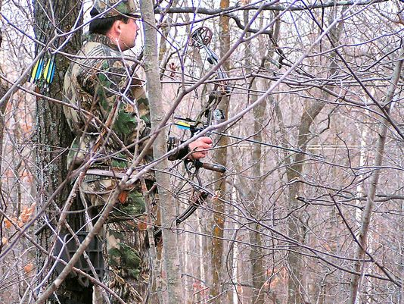

Story Highlights
- 11 states prohibit the sport on Sundays
- In North Carolina, the powerful Farm Bureau is against Sunday hunting
- Some states are willing to bend just enough to allow bow hunting on Sundays
ASHEVILLE, N.C. — Lawmakers and hunting advocates in North Carolina and three other states are working to change "blue laws" that ban hunting on Sunday. Eleven states prohibit the sport on Sunday, most for long-standing religious reasons, including Connecticut, Delaware, Maine, Maryland, Massachusetts, New Jersey, North Carolina, Pennsylvania, South Carolina, Virginia and West Virginia, according to the Coalition to Lift State Bans on Sunday Hunting. Discussions are also underway in Connecticut, Massachusetts and West Virginia to change that.
In North Carolina, the law has been on the books since 1896 and has its roots in religious observance, much like the state's ban on selling alcohol before noon on Sunday. Sunday hunting supporters say property rights are increasingly behind changes to the laws.
"We are in a situation where a lot of people are being told what to do on their private land and I think that is where the issue comes in," said Jake McGuigan, director of government relations and state affairs at the National Shooting Sports Foundation in Connecticut.
Republican state Sen. Jim Davis said private property rights, and keeping North Carolina hunters from taking their business to other states, are the reasons behind his bill.
But the blue laws have their supporters. In North Carolina, the powerful Farm Bureau is against Sunday hunting.
"Part of that is, I guess, people don't want it on their land on Sunday because they are having family meals," said Curtis Hayes, public relations director for the group, which has 530,000 members. "They just think it's not the right thing to do on Sunday."
In West Virgina, a Facebook group is gathering names for a petition for a referendum next spring on hunting on private land. The page has 402 members. In Massachusetts, a bill by state Rep. Anne Gobi would allow bow hunting during deer season. The bill is in the state's House Committee on Ways and Means and will be considered this session, said Tony Barletta, staff director at Gobi's office. In Connecticut, the state Department of Energy and Environmental Protection is backing a bill that would allow Sunday deer hunting with bows, said Dennis Schain, the agency's communications director. He said it would help manage the deer population.
West Virgina Republican state Sen. Clark Barnes, who introduced the bill calling for the referendum, said Sundays are sometimes the only time hunters can get out in the woods.
"Many of them work during the week and would like to hunt on the weekends," he said.
Sunday hunting in his state would also attract business from the metro areas of Washington and Baltimore, he said.
http://www.usatoday.com/story/news/nation/2013/04/27/states-sunday-hunting-bans-blue-laws/2115281/

