Congress showing little flexibility on debt crisis
By Anne Flaherty January 7, 2013
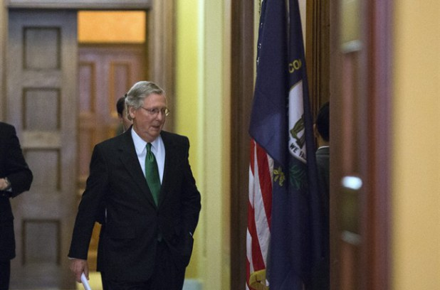 Senate Minority Leader Mitch McConnell, from Kentucky, departs the Strom Thurmond room after a Senate Republican caucus meeting about the fiscal cliff, on Capitol Hill, Monday, Dec. 31, 2012 in Washington.
WASHINGTON – Congressional leaders showed no signs of giving ground to resolve the next step in the financial crisis, with Democrats still talking about higher taxes on the wealthy and the Senate’s top Republican suggesting that a crippling default on U.S. loans was possible unless there were significant cuts in government spending.
“It’s a shame we have to use whatever leverage we have in Congress to get the president to deal with the biggest problem confronting our future, and that’s our excessive spending,” Senate Minority Leader Mitch McConnell said Sunday.
Last week’s deal to avert the combination of end-of-year tax increases and spending cuts known as the “fiscal cliff” held income tax rates steady for 99 per cent of Americans but left some other major pieces of business unresolved.
By late February or early March, the Treasury Department will run out of options to cover the nation’s debts and could begin defaulting on government loans unless Congress raises the legal borrowing limit, or $16.4 trillion debt ceiling. Economists warn that a default could trigger a global recession.
Also looming are deep automatic spending cuts that are now scheduled to take effect at the beginning of March that could further erase fragile gains in the U.S. economy. Then on March 27, the temporary measure that funds government activities expires, and congressional approval will be needed to keep the government running. It’s one more chance to fight over spending
Lawmakers said debt talks will consume Congress in the coming weeks, likely delaying any consideration of an expected White House proposal on gun restrictions in the wake of the Connecticut school shooting.
Republicans say they are willing to raise the debt ceiling but insist any increase must be paired with significant savings from government benefit programs. Democrats are reluctant to make deep cuts to Medicare, the government program that provides health care coverage for the elderly, and Medicaid, which covers the poor.
President Barack Obama has said he’s willing to consider spending cuts separately but won’t bargain over the government’s borrowing authority.
“One thing I will not compromise over is whether or not Congress should pay the tab for a bill they’ve already racked up,” Obama said in his weekly radio and Internet address.
Democrats said further tax increases for the wealthiest Americans were still possible as Congress looks to close the gap between revenues and expenditures. Democrats point out that Obama has already agreed to significant spending cuts, and that the latest deal only gets the nation to about half of the revenue it needs to resolve the red ink.
“Trust me, there are plenty of things within that tax code — these loopholes where people can park their money in some island offshore and not pay taxes. These are things that need to be closed. We can do that and use the money to reduce the deficit,” said Sen. Dick Durbin, the second-ranking Senate Democrat.
House Democratic leader Nancy Pelosi said she, too, wants to put “everything on the table from the standpoint of closing loopholes.”
But McConnell bluntly declared that the “tax issue is over” after last week’s agreement.
“We don’t have this problem because we tax too little; we have it because we spend too much,” McConnell said.
Making the rounds on the Sunday talk shows, McConnell was asked repeatedly whether Republicans were prepared to see the nation default on its spending obligations. McConnell said that wouldn’t be necessary, so long as Obama agrees to the spending cuts.
But at one point, when asked by NBC’s David Gregory whether the Republican strategy will be to hold the debt ceiling “ransom” in exchange for spending cuts, McConnell said it was a “shame we have to use whatever leverage we have” to get the president’s attention.
“None of us like using situations like the sequester (automatic across-the-board spending cuts) or the debt ceiling or the operation of government to try to engage the president to deal with this,” McConnell said.
Republican Sen. Lindsay Graham didn’t dismiss the idea of allowing a partial shutdown of government until an agreement can be reached. Sen. John Cornyn and other Republicans have floated the idea of a shutdown as a way of winning deeper spending cuts.
“I believe we need to raise the debt ceiling, but if we don’t raise it without a plan to get out of debt, all of us should be fired,” Graham said.
Rep. Chris Van Hollen, the top Democrat on the House Budget Committee, said the Republican strategy amounted to: “Give us what we want … or we’re going to tank the United States economy.”
Pelosi said she believes the president has enough authority under the 14th Amendment of the U.S. Constitution to raise the debt ceiling without Congress’ blessing. But the White House has said previously that it does not believe that the amendment — which says the “validity” of public debt shouldn’t be questioned — gives the president that power.
http://metronews.ca/news/world/498320/congress-showing-little-flexibility-on-debt-crisis/

- Summarize the Republicans point-of-view in dealing with this financial situation.

- Summarize the Democrats’ point-of-view in dealing with this financial situation.

- What percent of Americans will not see a rise in their income taxes?

- Republicans say they will agree to raise the debt ceiling if what happens?

- In your opinion, which side appears to make more sense? Justify your response.

