113th Congress: One of the Most Inexperienced in History
Susan Davis January 17, 2013
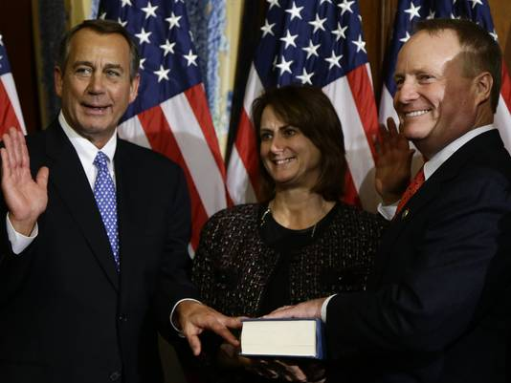Rep. David Joyce, R-Ohio, right, was given a seat on the Appropriations Committee.

WASHINGTON — Unproductive and unpopular are two words most often used to describe the previous Congress, but a new description can be used for the new session: inexperienced. A confluence of factors — from a trio of wave elections, redistricting, divisive primaries to even death — kick off a 113th Congress populated by junior lawmakers in both chambers that challenges the conventional wisdom that Washington politics is dominated by entrenched incumbents.
Nearly two in five lawmakers in the U.S. House, 39%, have served for less than three years, according to data compiled by the non-partisan Cook Political Report. It's the least experienced House since at least 1995, when an election wave swept the Republicans into power. The experience gap is more acutely felt within the GOP, which controls the House, where 46% of the 233 Republicans have served for less than three years. Among the 200 House Democrats, 61 lawmakers, or 31%, have three or fewer years on their résumé. There are two vacancies.
That means junior lawmakers now hold positions it once took years to reach. For example, two freshman Republicans, Reps. David Joyce of Ohio and David Valadao of California, were given seats on the Appropriations Committee, which determines federal spending. Another freshman, Rep. Richard Hudson, R-N.C., already chairs a Homeland Security subcommittee. They were sworn in just two weeks ago.
The dominance of inexperienced lawmakers has proven a challenge for House GOP leaders, led by House Speaker John Boehner, R-Ohio, who must not only build support for their legislative agenda, but also teach lawmakers the legislative process itself. The 2010 Tea Party wave washed in a group of lawmakers who had never held office before and ran as anti-establishment candidates. While that factor was diminished in 2012, the freshman class still features novice legislators, such as Rep. Ted Yoho, R-Fla., a large-animal veterinarian, and Rep. Kerry Bentivolio, R-Mich., a reindeer farmer. Yoho, who campaigned on a promise to shake up Washington, voted against Boehner for speaker on the first day of the session. His top aide is 24 years old.
The U.S. Senate has seen a 43% turnover rate since 2008. Since then, 23 senators have retired, six resigned, eight lost general elections, three lost primary elections and three died.
"It's not just 'brain drain.' It's a loss of institutional knowledge and experience and how the Senate works and how to get things done," said Jennifer Duffy, a Cook election analyst. "You've also lost a real crop of dealmakers."
The Senate's institutional knowledge took a trio of hits recently with the death of Sen. Daniel Inouye, D-Hawaii, the nomination of Sen. John Kerry, D-Mass., to secretary of State, and the recent retirement announcement of Sen. Jay Rockefeller, D-W.Va. Combined, the three senators boast 106 years of service in the chamber. In recent years, the Senate has also lost some of its "lions," with the deaths of Sens. Ted Kennedy of Massachusetts and Robert Byrd of West Virginia, veteran lawmakers who played critical roles in shaping how the chamber operates today.
Don Ritchie, the Senate's historian, said the chamber is experiencing a generational shift similar to the late 1970s and early 1980s during the Watergate and Reagan eras, which also saw great turnover in Congress.
"A lot of this is cyclical, you have another generation coming in," Ritchie said, "There are very few senators left from that time period anymore."
The House turnover has not been seen since the early 1990s, when the 1992 redistricting, a wave of retirements and the 1994 sweep of Congress reshaped the lower chamber, said David Wasserman, a Cook analyst.
Change has positive effects, too, Ritchie said. "There's strength in institutions in having people with institutional knowledge, but it wouldn't be good if everyone was that way. It's good to have new blood," he said.
"People will say, 'Who will be the next Ted Kennedy or Robert Byrd?' But people didn't know in 1962 that Ted Kennedy was going to be the next Ted Kennedy … He had to grow in to it," he said, "Some of the people coming in now are going to be the future lions of the Senate."
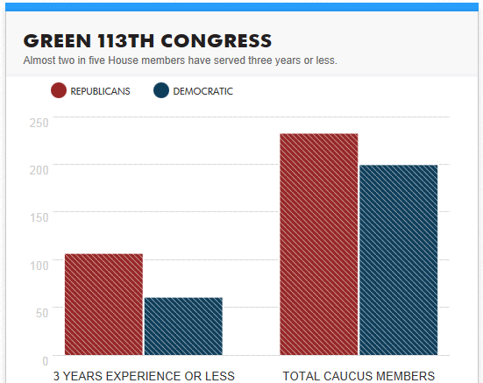
http://www.usatoday.com/story/news/politics/2013/01/17/113th-least-experienced-congress/1842265/

