A vote for workplace equality

There's wide support for protection from job discrimination
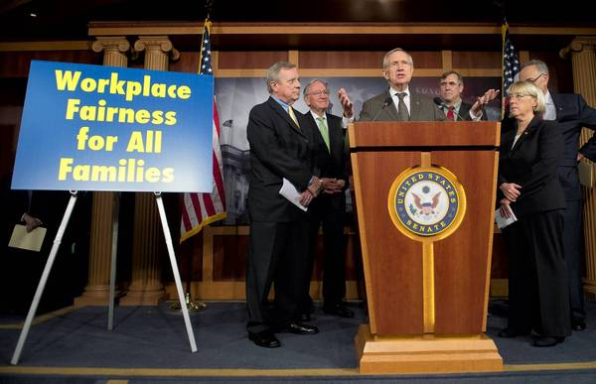 Senate Majority Leader Harry Reid, center, with Sens. Dick Durbin of Illinois, from left, Tom Harkin of Iowa, Jeff Merkley of Oregon, Patty Murray of Washington and Charles Schumer of New York, talks about the Employment Non-Discrimination Act.
November 11, 2013
In 1996, by a 50-49 vote, the U.S. Senate defeated a bill outlawing job discrimination on the basis of sexual orientation. Last week, in a step that dramatized how much attitudes have changed in recent years, the Senate approved a similar bill by a vote of 64-32.
It's about time the Senate got around to approving this. Since 1964, federal civil rights law has forbidden employment discrimination on the basis of race, color, religion, sex or national origin. But gays and lesbians have no protection, except in the states and cities that have passed laws including them. In the rest of the country, an exemplary worker may be punished or fired merely for coming out of the closet.
The Senate is actually lagging the American people on this issue. In 1993, a Gallup poll found that 80 percent thought gays and lesbians were entitled "equal rights in terms of job opportunities." The last time Gallup asked, the figure was up to 89 percent. Most people, in fact, think it's already against the law to fire someone on the basis of sexual orientation. That's probably because Americans generally regard such discrimination as grossly unfair and unwarranted, and find it hard to imagine that the law would not treat it as so.
The case for the Employment Non-Discrimination Act, or ENDA, is self-evident. Sexual orientation and gender identity have no more relevance to one's ability to perform on the job than skin color or religion. If a company can't reject an applicant for being a fundamentalist Christian, a Latino or a woman, it's hard to see why it should be entitled to indulge a prejudice against gays, lesbians or trans-genders.
One striking fact about ENDA is that none of the senators who voted against the bill spoke on the floor in favor of blessing discrimination against this particular group. As William Saletan noted in Slate, "Only one senator spoke against the bill, and only about religious exemptions." Opposing it on that basis doesn't make much sense either. The measure contains a broad exemption for religious organizations. No church or parochial school would have to employ someone who is gay or lesbian.
For a long time, gays and lesbians have been victims of a great injustice in the American workplace. The House owes them at least a vote.
http://www.chicagotribune.com/news/opinion/editorials/enda-ct-edit-1111-20131111,0,6482214.story

Does L.A. need free Wi-Fi?
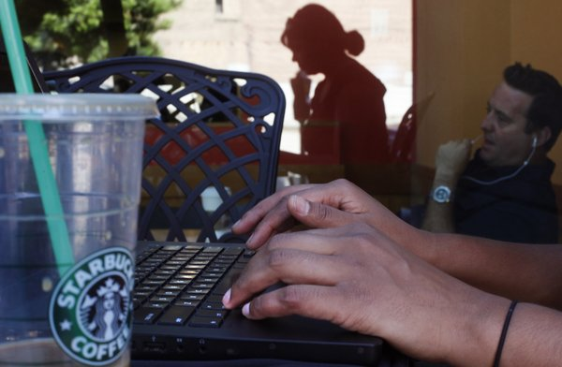 The City Council has revived the idea of creating a broadband network that provides free wireless Internet access throughout the city.
November 8, 2013
The City Council is rushing to revive an idea it left for dead four years ago: creating a broadband network that provides free wireless Internet access throughout the city. On Wednesday, the council instructed city technology officials to draft an invitation for contractors to bid on the project. But before the council gets too enamored with the idea of free Wi-Fi for all, it needs to take a hard look at how best to bring broadband access to those who need it most.
There's no shortage of broadband in the city. According to the state Public Utilities Commission, 99.6% of the households in Los Angeles County had access to high-speed connections by the end of 2011, if they wanted and could afford them. But only about two-thirds of the city's residents actually connect via broadband at home, a Public Policy Institute of California survey found. That's a lower rate than in any other urban area in the state.
Then-Mayor Antonio Villaraigosa announced plans for a citywide Wi-Fi network in February 2007, arguing that it would encourage economic development and narrow the "digital divide" between those who had broadband and those who didn't. City leaders around the country shared Villaraigosa's ambition, and more than 200 projects were eventually announced. But most of them, including Los Angeles', were abandoned in the face of high costs and other problems that proved insurmountable. Building a citywide Wi-Fi network in Los Angeles was expected to cost more than $60 million back then; the estimates go as high as $100 million now.
New Councilman Bob Blumenfield resurrected the idea shortly after taking office in July, arguing that the demand for connectivity today is greater, the cost of providing it lower and the consequences of not being online more severe. He also contends that broadband is an essential part of local infrastructure in the 21st century, vital to attracting investment and tourism.
Those are all good points, but the right response isn't necessarily to build a network covering the entire city — including neighborhoods and commercial areas that are already well served. Nor does providing free broadband automatically close the digital divide; people also need computers and the skills to use them. Thankfully, the council hasn't committed to any particular approach or technology. Instead, it simply instructed the Information Technology Agency to come up with a request for proposals that might entice a vendor to "build out ... some level of free broadband service to all city residents."
Ideally, the city will identify where the real gaps are in connectivity, then attract partners in the telecommunications industry to fill them. But it's not enough just to offer private operators money-saving access to the city's utility poles and conduits; the city's plan has to enable its partners to cover the cost of running and maintaining the network for years to come. If it can't meet those thresholds, then the new plan seems destined to meet the same fate as the old one.
http://www.latimes.com/opinion/editorials/la-ed-wifi-los-angeles-20131108,0,399046.story#axzz2kM9CK1Ex

Have the food police taken over?
E. Thomas McClanahan | The Kansas City Star Oct. 06, 2012
When does a movement that once seemed reasonable begin to slip its moorings? When first lady Michelle Obama began her anti-obesity campaign, I thought, Yeah, seems like a good idea. Get the kids outside and by all means, limit their intake of sugar water, er, soda. But worrisome signs were there from the beginning, evident in the campaign against cigarettes.
The health reasons were valid, no denying. But the effort was freighted with an extraordinarily high snottiness quotient. Anti-smoking neurotics would stage phony coughing fits if a guy across the street lit up. The world is full of people who Know How You Should Live, and they’re always looking for excuses to advise you on your errors. All that self-righteous preaching about the evil weed almost made me want to start smoking again. The anti-tobacco movement largely succeeded and it showed how the same approach can be applied to other behaviors. Soon, you had New York Mayor Michael Bloomberg ranting about trans fats and sodas, and yeah, the health reasons are there but, c’mon. This is the government, telling you how to live right down to ounces of consumption.
Anybody see a problem here? Slippery slope, anyone?
Bloomberg’s latest obsession is sweets in the hospitals. The other day he announced a campaign to have sugary and fatty foods eliminated from all hospitals, public and private. It’s supposedly “voluntary,” but this bandwagon has momentum and hospitals are signing on. So if you’re in New York and you’re stuck in the waiting room, sorry, no candy bar.
“If there’s any place that should not allow smoking or try to make you eat healthy, you would think it’d be the hospitals,” Bloomberg said. Notice the choice of words. Mayor Mike wants to make you.
Now the harvest of Michelle Obama’s work is being rolled out in the form of federally acceptable menus under the Healthy Foods Act. The kids and the moms are not amused.
In Greeley, Colo., the school district has outlawed all sweets, including cupcakes, candy bars and yes, birthday cakes. Ah, there’s an exception. The kids can have cake in school if mom follows a district-approved recipe. But school fundraisers, even those off-campus, may not include sweets. For fundraisers on school grounds, no food items of any kind are allowed. Think about that. We’ve gotten to the point of government-approved cake recipes.
At Wallace County High in Sharon Springs, Kan., teacher Brenda Kirkham posted a Facebook photo of a school lunch, the same fare served to students: one cheese-stuffed bread stick, a small dollop of marina sauce, three apple slices and some raw spinach. According to The Wichita Eagle, Kirkham supplemented with a few cubes of ham, bacon bits and dressing from the faculty-only line.
Kirkham’s photo prompted students and teachers to create a YouTube parody entitled “We Are Hungry” that tells the story of a famished 16-year-old football player who daydreams about his mom’s cooking. Students hide food in their lockers. Members of the volleyball team faint from hunger. Students sing, “Give me some seconds, I/ I need some food today/ My friends are at the corner store/ Getting junk so they don’t waste away.”
The feds, in their wisdom, have decreed calorie maximums for school lunches — 650 for elementary school students, 700 for middle-schoolers and 850 for kids in high school — a standard Kirkham called “ridiculous” for student athletes who work out three times a day and do farm chores. Supporters of this crusade tell me not to worry. The slippery-slope risk is exaggerated. Besides, the nation faces an obesity crisis and all these government functionaries with their one-size-fits-all rules have our best interests at heart.
But in a matter as personal as what we eat, how much trust should we put in people who don’t trust us?
http://www.mcclatchydc.com/2012/10/06/170222/commentary-have-the-food-police.html

The grim economics of food stamps

Trimming benefits for millions of poor Americans is not just callous, it's bad for the recovery.
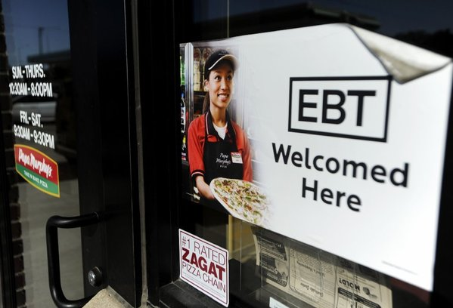 On Friday, the federal government rolled back Food Stamp benefits for all 48 million people who receive them. Above, a sign notifies customers that EBT can be used at a store in Sioux Falls, S.D. (Jay Pickthorn / The Argus Leader / Associated Press)
November 3, 2013
The day after Halloween, the federal government rolled back food stamp benefits for all 47.6 million people who receive them, officially ending one of the last remaining stimulus efforts left over from President Obama's first months in office — while also making it harder for millions of Americans to get enough to eat. The callousness displayed in cutting vital safety net benefits at a time when millions lack the resources to feed their families adequately has been much discussed. What has gotten less attention is that the cut in food stamps is not good economic policy either.
The 5.5% reduction in benefits will pull about $5 billion in federal spending out of the economy over the coming 10 months. Those were borrowed dollars, so the savings bring Washington one small step closer to fiscal sustainability. Yet the federal government won't make it all the way there without faster economic growth, and putting less food on poor Americans' tables won't help.
Congress increased the maximum food stamp benefit by 13.6% in April 2009 as part of the American Recovery and Reinvestment Act, a $787-billion effort to stimulate the economy. It wasn't a temporary increase; instead, it was meant to pay in advance the cost-of-living adjustments that the program was expected to receive over the subsequent five years. And because food stamp benefits are spent quickly, not saved, the increase was expected to help stimulate the moribund economy. By one estimate, every $1 in food stamps leads to $1.70 in economic activity.
But lawmakers soon siphoned off some of the budget for higher food stamp benefits, using it to help pay for Medicaid benefits, teacher salaries and a childhood nutrition program. As a result, rather than keeping food stamp benefits at the higher level until inflation caught up, the benefits were cut across the board Nov. 1. For a family of four, the maximum monthly benefit will shrink by $36, to $632. For the average recipient, the aid will drop to $1.40 per meal.
Even with the lowered benefits, the price tag for food stamps — formally known as the Supplemental Nutrition Assistance Program — is enormous, costing close to $80 billion a year. That's because the deep recession caused food stamp rolls to expand rapidly, and stubbornly high unemployment has kept the number of recipients from dropping. The new farm bill that lawmakers are negotiating will almost certainly shrink that number because both chambers want to make fewer people eligible for the benefits.
The percentage of the population on food stamps is alarming, but lawmakers shouldn't mistake a symptom of the economy's problems for its cause. They also have to recognize, as they try to navigate their way out of massive, recession-fueled deficits, that pulling federal dollars out of the economy has consequences too. It's a balancing act. The best way to cut spending on food stamps isn't to lower benefits or make them harder to obtain, it's to speed up economic growth and put jobless Americans back to work. That also happens to be the most effective way to reduce the deficit.
http://www.latimes.com/opinion/editorials/la-ed-foodstamps-cut-budget-20131103,0,5981150.story#axzz2kM9CK1Ex

Going Green' Costing US Greenbacks for Little Reward
Stephen DeMaura | Nov 10, 2013
The Washington Examiner conducted an analysis of the tangible impact of LEED standards in New York City, asking the one question that matters: do LEED certified buildings use less energy on a relative basis than non-LEED certified buildings? The answer: No. The Examiner analysis found that buildings with LEED certifications use more energy per square foot than buildings without the certification.
LEED certification was developed and championed by the U.S. Green Building Council (USGBC) – which is not a government entity, but a private group – which profits from this faux certification boom and describes themselves as being "committed to a prosperous and sustainable future for our nation through cost-efficient and energy-saving green buildings."
In fact, I would have no problem with LEED standards if they were completely voluntary within the private sector – that is, if those builders that wanted LEED certifications were able to get them and those that didn't were not forced to comply. But the USGBC managed a coup - somehow convincing (or bullying) the federal government, as well as more than 400 state and local communities that LEED standards were in the public's interest. Such is not the case. First, the National Research Council estimates that this green building mandate adds 8 percent to design and construction costs.
But, beyond strict costs, LEED standards have two main flaws: they are impractical and ineffective. On the impractical front, LEED standards prevent buildings from using certain safety materials, including bulletproof glass, in courthouses, prisons and other government buildings. LEED standards don't account for the fact that government buildings are high-profile targets, and safety measures should be determined by public safety professionals not by environmental profiteers like those at the USGBC.
The USGBC also arbitrarily mandates that the wood used in LEED buildings be certified by the Forest Stewardship Council (FSC), a favorite standard of fringe environmental groups, including Greenpeace. Most American forests are certified using two other standards – the American Tree Farm System and the Sustainable Forestry Initiative. May seem like semantics, but it is not. As a result of this deliberate decision, 90 percent of timber used is from foreign sources. In effect, LEED standards are shipping jobs overseas.
But these standards are also less effective. Some environmentalists are critical of the FSC - noting that the FSC is biased towards large conglomerates and that shipping timber from afar increases consumption of gasoline and emits more greenhouse gasses.
Fewer jobs alongside dubious results - these are not outcomes federal, state and local governments should mandate. Reversing strict adherence to LEED standards, in addition to other arbitrary “green energy” initiatives, will help leaders realize these programs are impractical and ineffective in their goal of reducing energy consumption, while the regulations also negatively impact thousands of workers and families in their area.
http://townhall.com/columnists/stephendemaura/2013/11/10/going-green-costing-us-greenbacks-for-little-reward-n1743385/page/full

