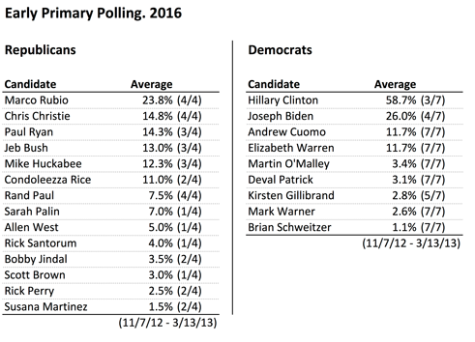

Muddled Republican Presidential Field for 2016
Jim Malone April 03, 2013
WASHINGTON — A new public-opinion poll finds there is no clear front-runner among potential Republican presidential contenders for the 2016 election.

Quinnipiac pollster Peter Brown has been looking at some of the potential Republican candidates and says the field appears wide open at this early stage. “What we found is that there is no real front-runner for the Republican nomination. There are a number of potential candidates, five actually, who got between 10 and 19 percent of the vote," he said.

The poll found Florida Senator Marco Rubio leads the group of potential Republican presidential contenders with 19-percent support. Wisconsin Representative Paul Ryan followed with 17 percent, Kentucky Senator Rand Paul had 15 percent, New Jersey Governor Chris Christie was at 14 percent and former Florida Governor Jeb Bush had 10 percent.

Most of the presidential contenders in both parties are not likely to announce their intentions about 2016 until after next year’s midterm congressional elections.
Pollster Peter Brown says Quinnipiac will come out with a new survey next month looking at the possible Democratic contenders for 2016, since President Barack Obama is limited to two terms. “On the Democratic side there is a question as to whether former Secretary of State Hillary Clinton will run. We have not polled on it yet, but we have in some states and she does very well," he said.

An ABC News-Washington poll in January found 67 percent of those asked had a favorable opinion of Clinton, who has served as secretary of state, senator and first lady.
A new Marist poll found that if she ran in 2016, Clinton would beat most of the Republican contenders easily, except for Governor Christie of New Jersey, who trailed her by only three points, 46 to 43.

Vice President Joe Biden may also be interested in running in 2016 on the Democratic side. And the race could also attract some new faces to the national scene, including New York Governor Andrew Cuomo and Maryland Governor Martin O’Malley.
http://www.voanews.com/content/republicans-2016-primary-poll-president/1634071.html

