Federal nullification efforts mounting in states on gun rights, pot, other issues
DAVID A. LIEB June 24, 2013
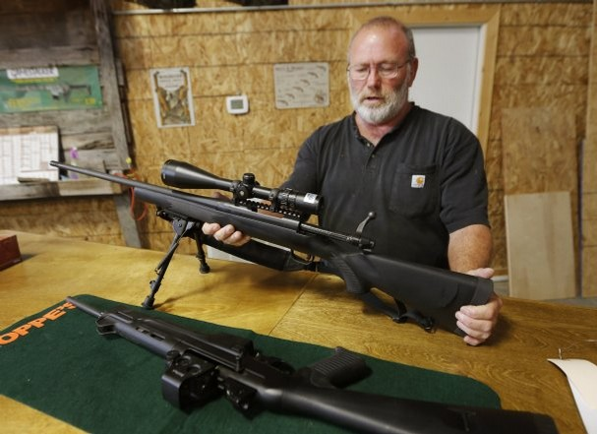Jim Sowash handles a rifle at his gun shop near Stover, Mo., Thursday, June 20, 2013. Sowash signed a letter to Missouri Gov. Jay Nixon urging him to sign a bill nullifying federal gun laws.

JEFFERSON CITY, Mo. — (AP) — Imagine the scenario: A federal agent attempts to arrest someone for illegally selling a machine gun. Instead, the federal agent is arrested — charged in a state court with the crime of enforcing federal gun laws. Farfetched? Not as much as you might think.
The scenario would become conceivable if legislation passed by Missouri’s Republican-led Legislature is signed into law by Democratic Gov. Jay Nixon. The Missouri legislation is perhaps the most extreme example of a states’ rights movement that has been spreading across the nation. States are increasingly adopting laws that purport to nullify federal laws — setting up intentional legal conflicts, directing local police not to enforce federal laws and, in rare cases, even threatening criminal charges for federal agents who dare to do their jobs.
An Associated Press analysis found that about four-fifths of the states now have enacted local laws that directly reject or ignore federal laws on marijuana use, gun control, health insurance requirements and identification standards for driver’s licenses. The recent trend began in Democratic leaning California with a 1996 medical marijuana law and has proliferated lately in Republican strongholds like Kansas, where Gov. Sam Brownback this spring became the first to sign a measure threatening felony charges against federal agents who enforce certain firearms laws in his state.
Some states, such as Montana and Arizona, have said “no” to the feds again and again — passing states’ rights measures on all four subjects examined by the AP — despite questions about whether their “no” carries any legal significance.
“It seems that there has been an uptick in nullification efforts from both the left and the right,” said Adam Winkler, a professor at the University of California at Los Angeles who specializes in constitutional law.
Yet “the law is clear — the supremacy clause (of the U.S. Constitution) says specifically that the federal laws are supreme over contrary state laws, even if the state doesn’t like those laws,” Winkler added.
The fact that U.S. courts have repeatedly upheld federal laws over conflicting state ones hasn’t stopped some states from flouting those federal laws — sometimes successfully. About 20 states now have medical marijuana laws allowing people to use pot to treat chronic pain and other ailments — despite a federal law that still criminalizes marijuana distribution and possession. Ceding ground to the states, President Barack Obama’s administration has made it known to federal prosecutors that it wasn’t worth their time to target those people.
Federal authorities have repeatedly delayed implementation of the 2005 Real ID Act, an anti-terrorism law that set stringent requirements for photo identification cards to be used to board commercial flights or enter federal buildings. The law has been stymied, in part, because about half the state legislatures have opposed its implementation, according to the National Conference of State Legislatures.
About 20 states have enacted measures challenging Obama’s 2010 health care laws, many of which specifically reject the provision mandating that most people have health insurance or face tax penalties beginning in 2014.
After Montana passed a 2009 law declaring that federal firearms regulations don’t apply to guns made and kept in that state, eight other states have enacted similar laws. Gun activist Gary Marbut said he crafted the Montana measure as a foundation for a legal challenge to the federal power to regulate interstate commerce under the U.S. Constitution. His lawsuit was dismissed by a trial judge but is now pending before the 9th U.S. Circuit Court of Appeals.
“The states created this federal monster, and so it’s time for the states to get their monster on a leash,” said Marbut, president of the Montana Shooting Sports Association.
The Supreme Court ruled in 1997 that local police could not be compelled to carry out provisions of a federal gun control law. But some states are now attempting to take that a step further by asserting that certain federal laws can’t even be enforced by federal authorities. A new Kansas law makes it a felony for a federal agent to attempt to enforce laws on guns made and owned in Kansas. A similar Wyoming law, passed in 2010, made it a misdemeanor. The Missouri bill also would declare it a misdemeanor crime but would apply more broadly to all federal gun laws and regulations — past, present, or future — that “infringe on the people’s right to keep and bear arms.”
U.S. Attorney General Eric Holder sent a letter in late April to the Kansas governor warning that the federal government is willing to go to court over the new law.
“Kansas may not prevent federal employees and officials from carrying out their official responsibilities,” Holder wrote.
Federal authorities in the western district of Missouri led the nation in prosecutions for federal weapons offenses through the first seven months of the 2013 fiscal year, with Kansas close behind, according to a data clearinghouse at Syracuse University. Felons illegally possessing firearms is the most common charge nationally. But the Missouri measure sets it sights on nullifying federal firearms registrations and, among other things, a 1934 law that imposes a tax on transferring machine guns or silencers. Last year, the federal government prosecuted 83 people nationally for unlawful possession of machine guns.
So what would happen if a local prosecutor actually charges a federal agent for doing his or her job?
“They’re going to have problems if they do it — there’s no doubt about it,” said Michael Boldin, executive director of the Tenth Amendment Center, a Los Angeles-based entity that promotes states’ rights. “There’s no federal court in the country that’s going to say that a state can pull this off.”
Yet states may never need to prosecute federal agents in order to make their point.
If enough states resist, “it’s going to be very difficult for the federal government to force their laws down our throats,” Boldin said.
Missouri’s governor has not said whether he will sign or veto the bill nullifying federal gun laws. Meanwhile, thousands of people have sent online messages to the governor’s office about the legislation. Signing the measure “will show other states how to resist the tyranny of federal bureaucrats who want to rob you of your right to self-defense,” said one message, signed by Jim and Arlena Sowash, who own a gun shop in rural Stover, Mo.
Others urged a veto.
“Outlandish bills like this — completely flouting our federal system — make Missouri the laughingstock of the nation,” said a message written by Ann Havelka, of the Kansas City suburb of Gladstone.
http://www.courierpress.com/news/2013/jun/24/federal-nullification-efforts-mounting-in-states/

- What would a proposed Missouri law allow to happen to federal agents? Why?
- What does “nullify” mean?
- Which 4 issues have seen states make laws in contrast to federal laws?
- What does the Supremacy Clause in the U.S. Constitution state?
- How have federal courts typically ruled in cases with conflicting state and federal laws?
- Why hasn’t the federal law dealing with marijuana been enforced?
- Why hasn’t the 2005 Real ID Act been implemented?
- Should states be allowed to pass laws that go against federal laws? Why or why not?

