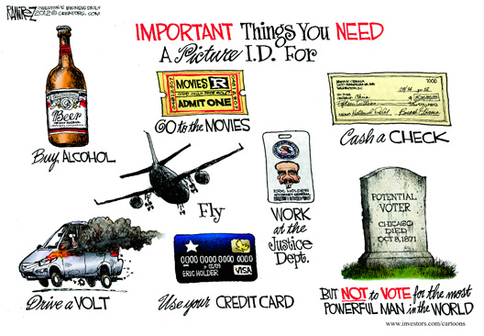
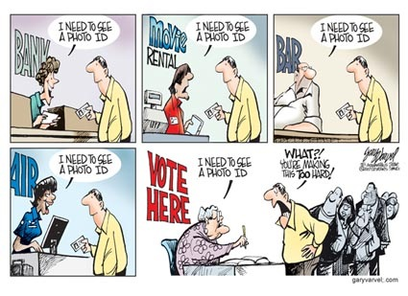
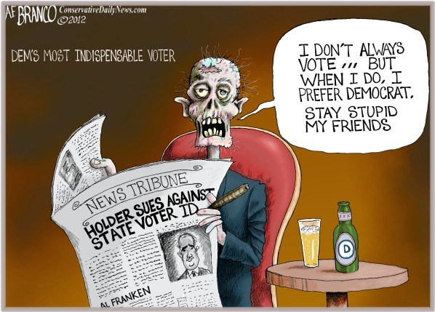
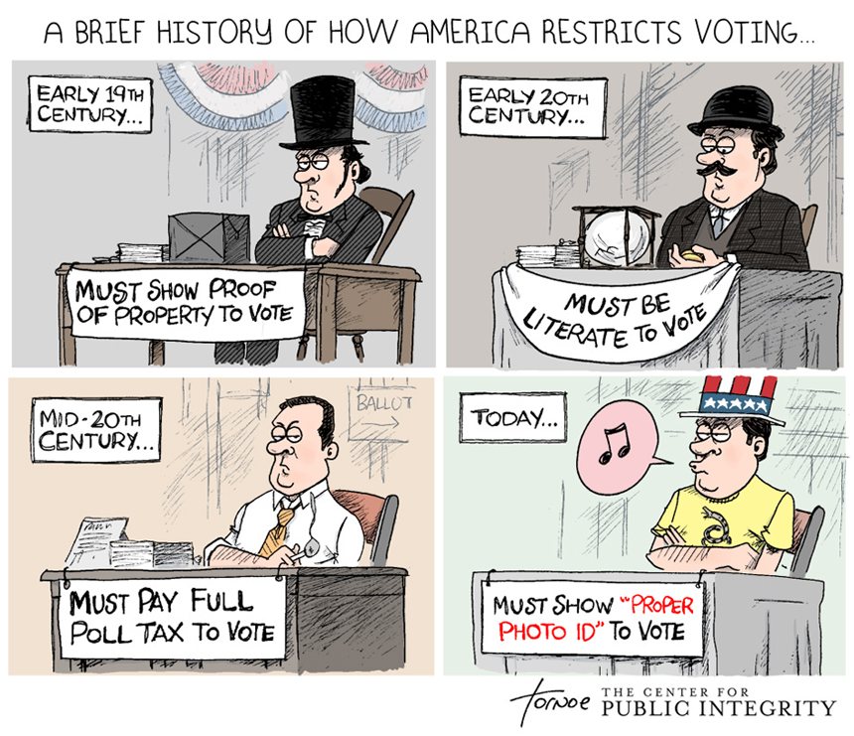
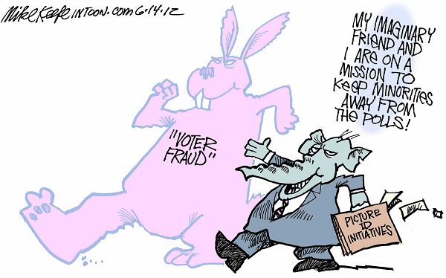
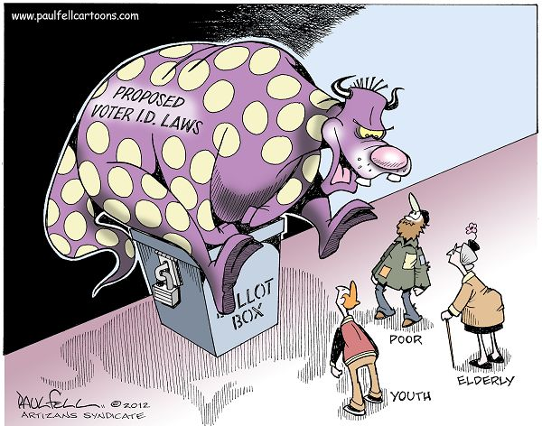
Table 1. State Requirements for Voter Identification
States that Request or Require Photo ID |  |  |  | States that Require ID (Photo Not Required)
Strict Photo ID  In effect in 2012:  Georgia  Indiana  Kansas  Tennessee  Not in effect in 2012:  *Mississippi (6)  *Pennsylvania (7)  **South Carolina (1)  **Texas (1)  *Wisconsin (2) |  | Photo ID  In effect in 2012:  Florida  Hawaii  Idaho  Louisiana  Michigan  New Hampshire  South Dakota  Not in effect in 2012:  **Alabama (1), (5) |  | Strict Non-Photo ID  In effect in 2012:  Arizona  Ohio  Virginia |  | Non-Strict Non-Photo ID  In effect in 2012:  Alaska  Arkansas  Colorado  Connecticut  Delaware  Kentucky  Missouri  Montana  North Dakota  Oklahoma (3)  Rhode Island (4)  Utah  Washington
South Dakota  §12-18-6.1 and 6.2 | When a voter is requesting a ballot, the voter shall present a valid form of personal identification. |  | - South Dakota driver’s license or nondriver identification card  - U.S. passport  - Photo ID issued by an agency of the U.S. government  - Tribal ID card, including a photo  - Student ID card, including a photo, issued by an accredited South Dakota school |  | If a voter is not able to present a form of personal identification as required, the voter may complete an affidavit in lieu of the personal identification. The affidavit shall require the voter to provide his or her name and address. The voter shall sign the affidavit under penalty of perjury.

