American Government
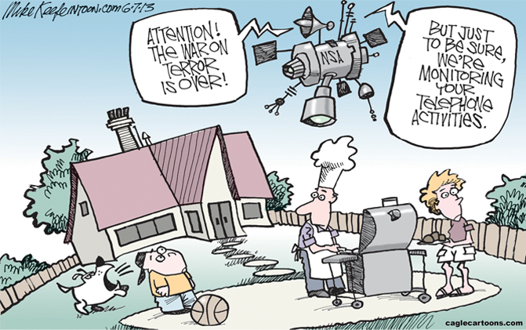

- The NSA spying machine’s announcement, “The war on terror is over!” refers to President Obama’s declaration last month that the nation should try to move beyond a perpetual war against Al Qaeda and other terrorist groups. How is the cartoonist using irony to make a point? What point do you think he’s making?

- It’s been reported that the data collection program has helped prevent terrorist attacks. Do you think that security measures like monitoring Internet activity and analyzing phone records make the nation safer?

- In your opinion, are most Americans willing to give up some privacy to prevent another terrorist attack on the U.S.?

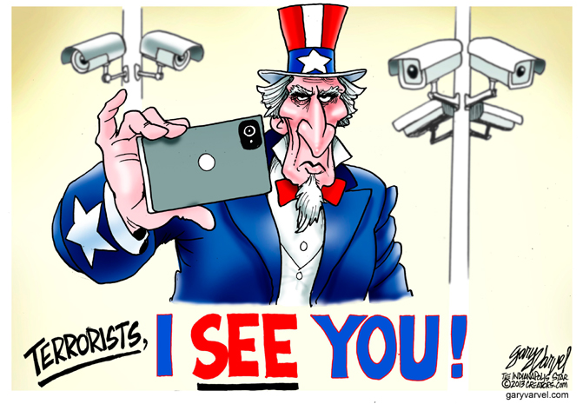

“Watching You”
Upfront magazine – September 2, 2013 – p. 6-7

- What recent government activities have led to questions about Americans’ privacy and security?

- Explain the following quote from President Obama. “You can’t have 100 percent security and also then have 100 percent privacy and zero inconvenience.”

- What is “Prism?”

- What is President Obama’s view of Prism?

- How does the Fourth Amendment to the Constitution protect Americans?

- List examples of monitoring in the United States.

- What does polling data reveal about Americans’ attitudes towards surveillance?

- What is your opinion or thoughts on this subject? How much privacy are you willing to give up for security? Has our government gone too far, not far enough, or acting appropriately? Explain your responses.

